Global-Offensive Artificial-Intelligence Bot Entity (GABE)

Tudor-Ștefan Păuleț

1. Introduction

Released in 2012, Counter-Strike: Global Offensive is a multiplayer first-person shooter game based on the interaction between the two teams: the Terrorists and the Counter-Terrorists. Although the game offers multiple game modes, the target of this application was the standard game-mode of bomb-defusal.

A round of a Counter-Strike match has one symmetric objective and an asymmetric one, any of them being achieved leading to a team victory. The common objectiv is eliminating the enemy team. The team-dependent goal is determined by the game-mode. In the standard game-mode mentioned above, the Counter-Terrorists have to prevent the Terrorists from planting the detonating the bomb in one of the predefined sites.

Since the game was launched, bots were always available in all game modes in order to provide balancing to the two teams; however, their behaviour has always been less than optimal and the only facility they actually provided was the capacity of players to control them after dying. In 2021, the bots were removed from the competitive mode of Counter-Strike, as the facility aforementioned was abused by players. In September 2023, Valve, the game developer, updated the engine behind the game from Source to Source 2 and renamed the game Counter-Strike 2 but the absence of bots in the competitve mode was kept. Bots are still present in the casual game modes and the practice environment.

Counter-Strike is one of the most popular multiplayer games and also one with the highest prize-money for competitive tournaments, amassing 15.11 million in 2023, and, because of this, Valve invested an important amount of time and resources in anti-cheat software (Valve Anti-Cheat – VAC) and making their game as inaccessible to interference from external sources as possible. For this reason, there exists a very limited API that provides game information. This makes any attempt to analyze the game, gather information of the current environment and interact with it a difficult task.

Given my passion for the game pre 2023 and considerable knowledge of the game mechanics, this application aims to be a rudimentary bot that is able to compete against the bots provided by Valve in a restricted environment of 1 vs 1 in the standard bomb-defusal mode. Moreover, the activity of playing a game is a task that involves a lot of decision making based on multiple factors and taking actions in parallel with a tight synchronization between them to achieve the goal. Given the challenging nature of Counter-Strike, but also the fact that this difficulty comes not from the numerous mechanics of the game but rather from the precision that top-level players have in these simple actions makes this project an interesting application.

2. Similar applications

The starting point for my application were the bots provided by Valve. Although the implementation is proprietary, the in-game behaviour provides certain key points:

* the bots are aware of the match state and attempt to improvise and adapt to the needs of the team; (**e.g.** the bots tend to stick together while defending sites)
* the bots are aware of the game state, actively contributing towards the current team objective; (**e.g.** if the bot is in the Counter-Terrorist and the bomb is planted, this will drive them towards the planting point to defuse the bomb)
* players are able to communicate with the bots through a number of predetermined commands; (**e.g.** pressing **Z** + **4** yields the command “Hold this position” to ask the bot to hold the current site)
* bots have difficulty levels that changed the accuracy of shooting and reaction speed; this is the only aspect of their behaviour that is influenced by difficulty
* the aim of the bots is based on the in-game information received from the engine; (**e.g.** they can follow a live target with perfect precision)

In a 2021 paper, Cheyang Dai [1] described an agent based on two deep neural networks that was able to play the game. The aim approach used by the author is sbased on a convolutional neural network (YOLO model [2]) and the success of the implementation encouraged me to proceed with this idea of using a deep neural network to recognise enemies. The movement mechanism, on the other hand, are based on a custom-made neural network. This approach has one considerable advantage: the ability of the bot to learn different movements by analyzing the behaviour of real players under the same circumstances. In this manner, obstacles and special transition places can become quite clear to the bot thourgh experience. On the other hand, I believe that the use of such a general approach misses on one key mechanic of the game: the movement of a player in a match relies heavily on the map being played. Map knowledge is crucial to an above-than-average player, and for this reason a bot that attempts to mimic human performances should be aware of more than just the immediate environment and have an overall understanding of the game-state and the possibilities available.

The most common interaction with Counter-Strike from a non human-controlled source is represented by the cheats that players used. Although Valved invested a tremendous amount of resources in their anti-cheat, the hackers still manage to produce cheats that are, sooner or later, cought by VAC, with the players being banned. However this race is still ongoing and as VAC evolves, so do hacks. But their target remains the same: aimhacks and wallhacks (see 7.10, 7.11). These cheats are usually based on direct memory reading or GPU reading, but some also use facilities that exist for developing purposes. For example, in developer mode there exists the possiblity to see player silhouettes through the wall and some older wallhacks made use of this feature to be used in competitive games.

3. Implementation details

3.0 Technical details

Almost all of the implementation of what is described below is in C++, more specifically C++20, with only a single module written in Python. Due to the low level dependencies (the window management system, see section 3.3), the target OS is Unix based (Arch Linux) with X11 being the required displayed server. The Counter-Strike application runs natively on the target OS. Only one external dependency exists, to CDS [8] for parsing JSON files.

Testing of the application was made on two computing units: firstly a desktop with 32 GB of RAM, a CPU with 12 cores and a Nvidia GTX1050TI graphics card; and secondly on a laptop with //todo specifications of laptop.

3.1 Task analysis

At first, a thorough analysis of the task at hand is required. Focusing on the target behaviour, meaning emulating a human player, the following must be achieved:

1. a precise aim, yet with a reaction speed that allows the opponent to react to your presence. Given the processing capabilities, it would be possible to create a bot that would kill any enemy as soon as it comes in the field of view. This would not pass as human behaviour.
2. movement through the environment, considering the possibility of obstacles and whether they can be jumped over. A standard Counter-Strike map provides the player with numerous obstacles that either require going through a certain spot to pass through or executing a different kind of movement (crouching, jumping).
3. aiming and anticipating possible enemy spots. In addition to recognising enemies, an important aspect of the gameplay is predicting spots where the enemy may camp9. An above average player on a map usually knows about these spots and can adapt his aim accordingly. An enemy can quickly eliminate a player if the player is not aware of the enemy's presence.
4. Team oriented behaviour. As previously stated, the Terrorists and the Counter-Terrorists have, in addition to the objective of eliminating one another, a map dependent objective. Considering the importance of this objective, a bot playing the game should always keep this as one of its goals and attempt to complete it.

Given the list of requirements, we will introduce the following constraints for achieving the initial solution:

1. the bot shall play on only one map (de_dust2) in the bomb-defusal scenario. Considering the many aspects that depend on the map being played, limiting to one is a resonable choice for the success of the implementation. In addition to this, de_dust2 is the most popular map in Counter-Strike that any player should recognise. On the other hand, the implementation shall be modular, meaning that adapting to a new map should be done solely through updates to the map representation.
2. the bot shall first learn to play for the Terrorist side. Given the more active role of a Terrorist, starting with this as an objective should yield better results, as the playstyle of a Counter-Terrorist depends more on the enemy that I have no control over.
3. shooting shall be the first priority of the bot. Considering that one of the two objectives of a Counter-Strike player is eliminating your enemy, the bot shall concentrate on shooting and making this a priority in all scenarios.

3.2 Environment analysis  
The second step in developing the application was the environment analysis. In order for the bot to interact with the environment, it first needs information about the state of the game, the position, the presence of enemies in the field of view, etc. As previously stated, Counter-Strike is strongly isolated from any external application trying to read or write any of the programs memory. Searching for an API that provides information regarding all the aspects that the bot needs to be aware of yielded only a single result: the Counter-Strike: Global Offensive Game State Integration (GSI) [3][4].   
Game State Integration is an API created by Valve to provide third-party applications to access information from a game in real time. This API is mainly used in major Counter-Strike tournaments to display player statistics, create real-time visual effects synchronized with important events of the match

**i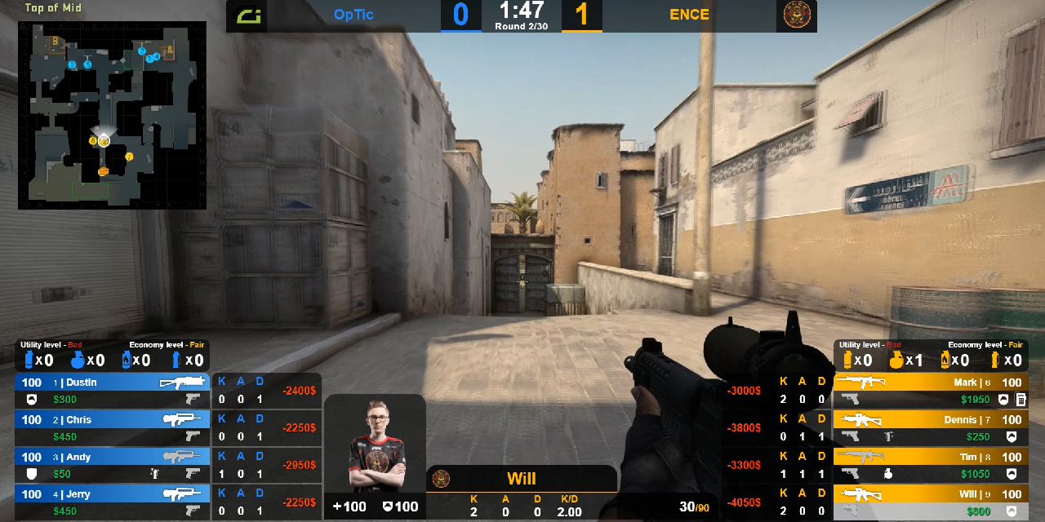mage 3.2.1** game state integration being used to display player information

(bomb plants, bomb defusals, aces, clutches) as can be seen in image 3.2.1. A thorough analysis of Game State Integration will be made in section 3.3.

Although GSI does provide considerable information, aspects such as the player position, the current map zone and the presence of enemies are not provided. The second source of information is a straight-forward one: the user interface (UI). An example of the standard Counter-Strike interface can be seen in image 3.2.2

In the top-left side exists a mini-map and below it, written in white, the current zone the player is in. The bottom side of the screen holds information regarding the player: inventory in the right side, the health, armour and ammo in the center and the money to the left. And of course, the presence of an enemy becomes obvious as soon as it comes in the field of view. Considering this large amount of information that the game provides through the UI, it might seem that other sources of information are redunant. However, as we shall see in section 3.3, although for humans it is easy to analyze an image, doing it progra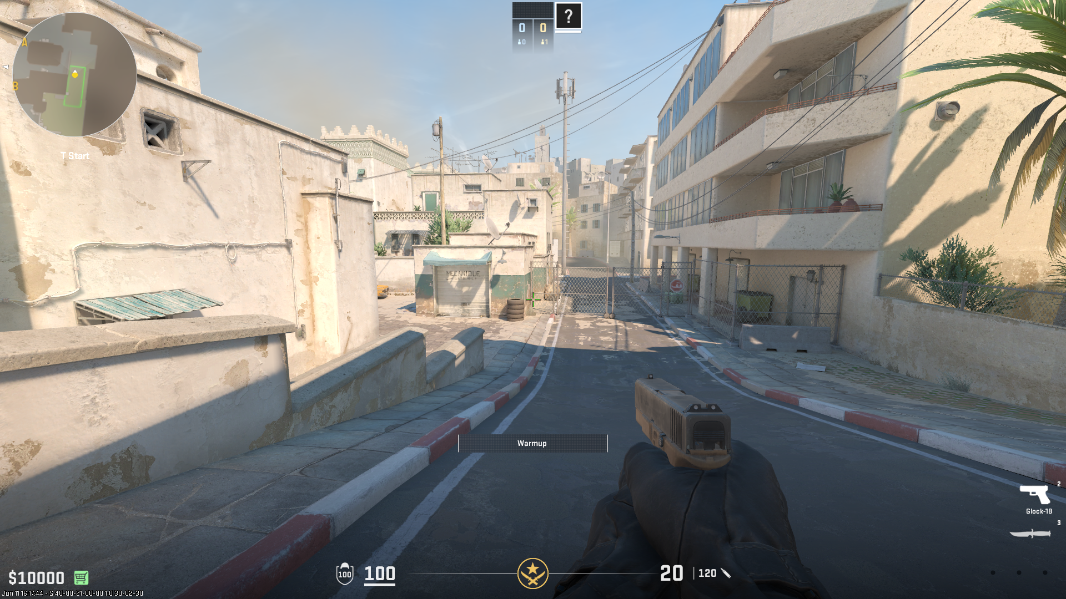matically is a much more difficult task.

**image 3.2.2** the standard Counter-Strike UI

The third and last source of information is the developer console. In order for most studios to enable their users to develop additional tools or mods or debug crashes of the game, they provide a way for the computer geek users to directly interact with the engine that powers the game. And Valve does provide such a mechanism through the developer console (image 3.2.3).

The developer console is a mechanism that must be enabled in the game options and after that it can be accessed through the ‘~’ key (or any other if this keybind is replaced in the options). This will create a pop-up window that allows the user to input predefined commands [5]. As we will see, the developer console is indeed a powerful mechanism and a crucial building block of this application.

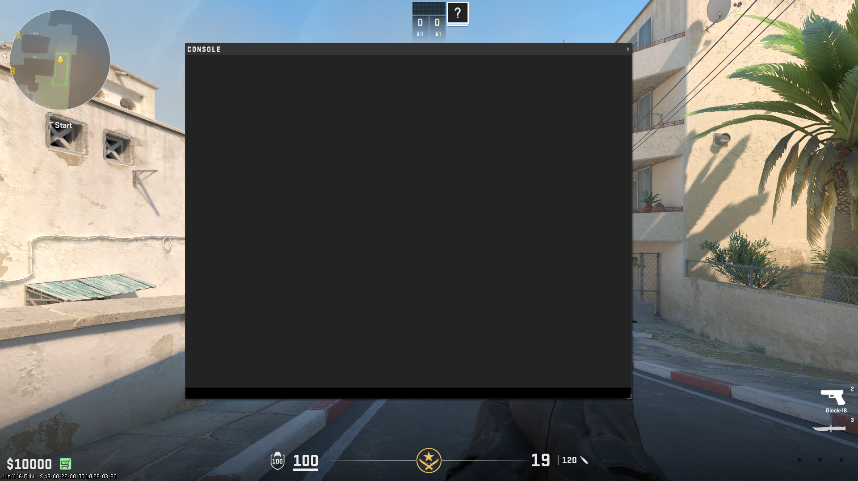

**image 3.2.3** the Counter-Strike developer console

The last environment entity that provides us with information is the map itself. In image 3.2.4 we can see a general overview of de_dust2. Considering its structure, entry points to different zones, obstacles and camping spots is crucial for a bot that aims to achieve points 2 and 3 discussed in section 3.1. Unforunately, there are only 2 sources of information available: the UI that was previously discussed and my personal knowledge gathered through playing the game on this map. As we shall see in the following sections, the first source is unreliable, as it does not provide all the necessary information. Therefore, map navigation will depend on the experience of other users, but mostly on the personal one.

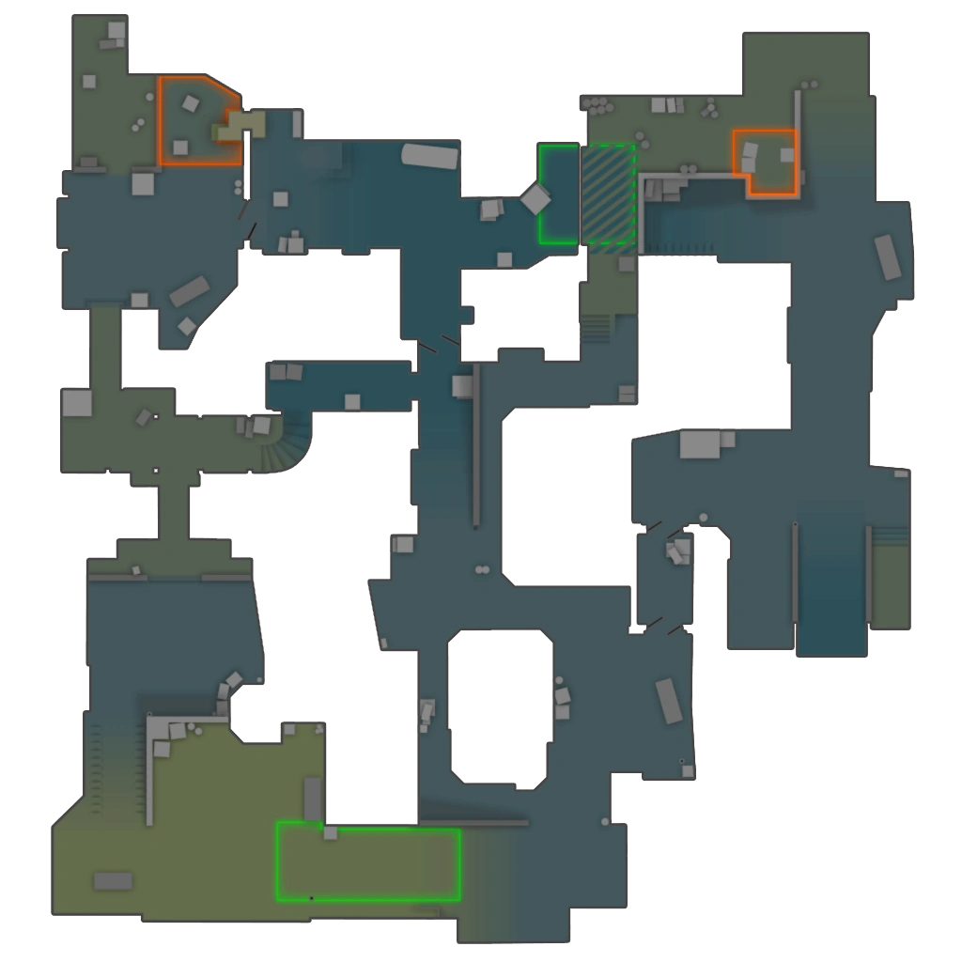

T spawn

B

CT

spawn

A

**image 3.2.4** overview of de_dust2

As can be seen, the map is divided in 3 major sides: the B side, on the left side of the map, the mid side, starting from above T spawn, and the A side, on the right side of the map. A further breakdown of the map will be needed in smaller regions, as shall be seen in section 3.3.

3.3 Application components

We have seen that the bot needs to be aware of a considerable amount of information and that there are multiple sources of information. In order to ensure that the design of the application follows the SOLID principles [7], each source of information shall be treated in a separate class and an aggregator class shall be responsible of passing the required data to the classes and aggregating the results. With that in mind, the following subsections will describe in detail the development process of each of these components.

3.3.1 Enemy detection

The main mechanic of Counter-Strike is shooting. The aim of a player represents an imporant part of his gameplay. For this reason, the aim of the bot consisted a very important aspect, if not the principle one. Because of this, an important amount of times was invested in developing this component and optimizing it to ensure the best performance.

As stated in section 3.2, the only source of information regarding enemy presence is the UI. The first idea was of using an object detection algorithm based on neural networks and, by using the said algorithm on live images from the game captured with the C++ application, to be able and recognise enemies present in the field of view.

Having no prior knowledge of image recognition or object detection, a thorough look through internet resources seemed like the only feasible option. Thanks to Ramona Albert, the process went much smoother, as she directed me towards the YOLO [9] algorithm and helped me with the appropriate resources.

Before diving into the particularities of YOLO, the task of object recognition must be understood. In a normal, classification problem on images, the task is simple: given a certain image that has only one central object and a set of possible labels, assign one of the labels to the image. The problem becomes considerably more difficult when the image does not focus on only one object, but rather it consists of different objects that may belong to different classes. In addition to simply labeling these objects, the task now also consists of identifying the region of the image where the object is placed. This spatial delimitation of objects is done through bounding boxes. Bounding boxes are tuples of 4 values: *(x1, y1, w, h)* that have the following meaning: *w* and *h* represent the width and height of the bounding box with *x1* and *y1* being either the coordinates of the center of the box, or the top left corner.

Having made this digression, we can now return to the problem at hand: as stated, we only wish to detect enemies. So the labeling process is not difficult as all, as there is only one label: the Counter-Terrorist label. The bounding box problem, on the other hand, is more challenging. The accuracy of the bot depends entirely on the accuracy of the bounding box prediction. So a state-of-the-art algorithm for object detection is needed to ensure the quality of requirement 3.1.1. Not only that, but our detections must also be fast. In a game such as Counter-Strike, where the reaction speed makes the difference between you shooting your enemy and your enemy shooting you, our bot needs to have a reaction speed comparable to the average reaction speed of players (that is about 150ms).

These requirements make YOLO the perfect candidate for the enemy detection task. The algorithm is based on a convolutional neural network (CNN) that is responsible both for predicting the bounding boxes and the labels of the identified objects. Convolutional neural networks represent the modern basis of object detection as they capture an important feature of human seight: proximity. Normal neural networks would analyze pixels independent of one another; CNNs on the other hand consider, in the analysis of the importance of a pixel, its neighbours. This is what gives CNNS the remarkable results in image recognition.

The backbone of convolutional neural networks are convolutional layers. Convolutional layers make use of the mathematical concept of a convolution [12] and do so by using kernels (matrices of weights). In contrast to fully connected layers, convolutional layers are defined through 2 parameters: the size of the kernel on the respective layer and the number of kernels present. This means that the data has a 3-dimensional shape while flowing through the network. By using this mechanism, CNNs are able to consider regions of the image instead of individual pixels.

Due to the large nature of images (**e.g.** a 640x640 RGB image has 1.228.800 pixels) convolutional neural networks have two mechanisms to reduce dimensionality: firstly, instead of considering convolutions over the entire image, convolutions are considered using a certain stride, meaning that certain rows and columns are skipped. Doing so produces outputs of lower height and width. Secondly, altered with convolutional layers, there are pooling layers that function somewhat like the convolutions: given a 3-dimensional input, pooling layers squash regions of the image given a certain policy and produce a 3-dimensional output of the same depth, but reduced width and height. For example, a 2x2 max-pooling layer processes the matrix in such a way that each 2x2 region produces a unique element, in this case the maximum out of the 4.

YOLO is a one-shot object detection algorithm; this means that by only running the image one time through the neural network, it outputs the bounding box predictions and labels. YOLO is also designed such that it can detect multiple objects present in the same image: the output is actually an array of *(bounding-box, label)* pairs. YOLO has gone through multiple stages of development, paper [2] describing the first version, YOLO v1. In order to keep things simple and considering my limited knowledge in the machine learning domain, I decided to use this version of YOLO.

The intention of the thesis is not to reuse the existing implementation. Therefore, the initial approach was to implement YOLO from scratch utilising the original YOLO v1 paper [2]. Since this is the most important building block in terms of speed, this implementation was written in C++: first of all, the ability to build a CNN with layers of custom sizes and activation functions; after that the ability to propagate forward an image and receive the prediction in the shape of an array; and last of all, the ability to backpropagate a prelabeled dataset in order to have a model that learns from the dataset and optimizes its weights.

Taking inspiration from Python’s Numpy library, I began the development of my machine learning library with a data structure that would represent the mathematical concept of a multidimensional vector: the LinearArray class.

LinearArray was built with one requirement from the get-go: the ability to catch as many errors as possible at compile time. In opposition to the way Python handles issues related to operations between numpy arrays of mismatching sizes, array resize into an invalid size and so on, the design of LinearArray was made such that all of these problems would be detected at compile time.

In order to keep the flexibility of a class capable of performing mathematical operations on vectors of any dimension, yet still handle any problems at compile time, as mentioned above, the building block of the LinearArray class were C++ Templates [9][10].

C++ Templates are “entities parameterized by one or more template parameters” that the compiler expands fully at compile-time, meaning that all the mentioned template parameters must be fully known at compilation. Through templates, C++ allows customization of functions and classes and, although the template parameters must be known at compile time, C++11 introduced variadic templates that allow an unspecified number of parameters (usually limited to 1024) to be passed as template parameters.

Another crucial feature of C++ Templates is template specialization: given a templated class, a part (partial specialization) or all the parameters (full specialization) may be specified in a new definition of the class template, allowing for an entirely new definition of the respective class. These two features combined allow for a powerful mechanism of creating self-recursive class definitions, the fundamental mechanism of LinearArray. This idea of self-recursion comes from the following: a 1-dimensional vector is a collection of values of a certain type. A 2-dimensional vector is a vector of 1-dimensional vectors. A 3-dimensional vector is a vector of 3-dimensional vectors. And so on. From this we can see the reasoning behind defining a LinearArray of n dimensions in terms of a LinearArray of n-1 dimensions.

The self-recursive definition of LinearArray may, at first, seem replaceable with a typical dynamic vector of vectors. However, using templates provides a number of advantages:

1. template coding encourages inlining; Inlining is an imporant feature of the C++ optimizer, when function calls are replaced with the body of the function and, by doing so, a lot of overhead is reduced and the performance is increased. Moreover, performance is further improved as the compiler has more knowledge about the code when parameters are constrained through templates.
2. determinism; Usage of templates instead of unconstrained self-inheritance provides an additional layer of safety. Defining a class recursively poses the danger of infinite recursion. Making use of template expansion ensures that in such a case, the compiler shall reach the template expansion limit and signal an error at compile time. Not only is this good because the error is caught earlier than at runtime, but it is also more explicit and easier to treat.
3. compile time assertions; As stated previously, all template parameters must be specified at compile time. This also allows us to make use of compile time assertions. Through them, out of bounds accesses, operations with LinearArrays of non-matching sizes or mathematical operations impossible on vectors of certain sizes can all be ensured at compile time.

With all of these being said, let’s dive into the actual implementation. In image 3.3.1.1 we can see definition of the generic LinearArray; it has a template type parameter, *DataType* that will represent the standard data type of the elements contained, a required non-type parameter *first_size* that prohibits LinearArrays of size 0 from existing and the last parameter *remaining_sizes* that is a variadic non-type parameter that allows for the self-recursion to happen. As can be seen, the class does not directly inherit itself, but he recursion happens, as we will see, through the LinearArrayContainer class.

**image 3.3.1.1** the generic LinearArray class definition

In image 3.3.1.2 we have the definition of the LinearArrayContainer class. As we see, it has two template parameters: the type template parameter *DataType* and the single non-type template parameters *s*. An important thing to remark here is that the *DataType* from this class is not the same as the one passed to the LinearArray class; the *DataType* parameter in LinearArrayContainer is another LinearArray (line two from image 3.3.1.1). As LinearArrayContainer has a member *_data* that contains *s* elements of type *DataType,* here is where the recursion happens and the relation between a n-dimensional vec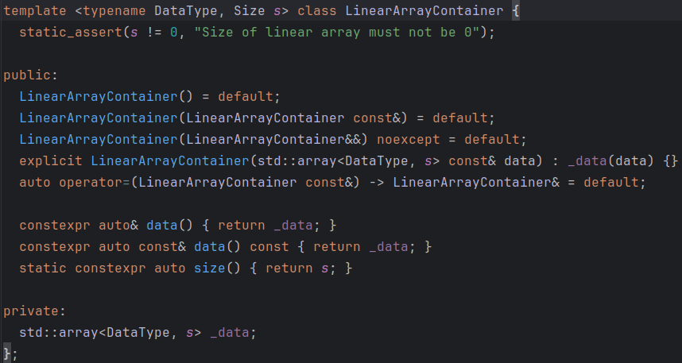tor and a (n-1)-dimensional vector can be clearly seen.

**image 3.3.1.2** the LinearArrayContainer class definition

The LinearArrayGenericOps represents a collection of operations invariant to the dimensionality of the array: addition, substraction, pairwise multiplication, applying transofmrations, reductions, iterating, etc. By separating the actual containment of data from the available operations, the Single Responsability and the Dependency Inversion principles are respected.

As any recursion, the LinearArray class must also have at least one base case: in our case there are two base cases.

The first one is the 1-dimensional array (image 3.3.1.3): the base non-recursive case. It has no dependency on a LinearArray of lower dimensions (as mentioned, 0-dimensional arrays would be ill-formed) and does not have any particular methods.

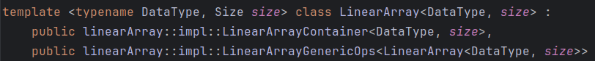**image 3.3.1.3** the base case LinearArray

The second one is the 2-dimensional array, representing the concept of matrix. Given the particular operations available (fliping, convolutions, transposing, matrix product, etc.) this base case was required to provide all these features. In contrast to the possibility of using the GPU for computation, a feature present in the Numpy library, all the computation done on matrices in my library are CPU bound. For this reason, the matrix product implementation makes use of multithreading for performance increase.

Another important feature of LinearArray is its serializability; due to the fact that the neural network implementation is based on the LinearArrays, serializing the network in a file after training comes down to serializing a lineararray.

Having already seen the benefits of using Templates earlier in this paper, more benefits arise from the chosen implementation. As can be seen in the LinearArrayContainer class, the underlying container for the LinearArray class is std::array. This type of array has the property that it is entirely allocated on the Stack. Such a memory allocation scheme ensures a very high performance, as the entire memory layout of the data structure is known and also, memory is allocated continuous therefore the CPU can take full advantage of the cache locality property.

The second step in implementing YOLO was the ability to build standard neural network, a precursor to the convolutional neural network required for object detection. Simple neural networks, as well as convolutional ones, depend on one key aspect: the relationship between adjacent layers: every layer must be aware of its successor in order to be able and feed information during forward propagation and also aware of its predecessor in order to send back gradients during backpropagation.

Every layers is characterized by two components: the size, that gives the number of neurons, and the activation function. The last layer is unique, as it also has a cost function associated. An important thing to note is that the size of a layer by itself holds little meaning, as the weights of the network are related to the sizes of adjacents layers. Considering all of these aspects, the building block of our neural network is the LayerPair class (image 3.3.1.4a) that aggregates instances of the Layer class (image 3.3.1.4b).

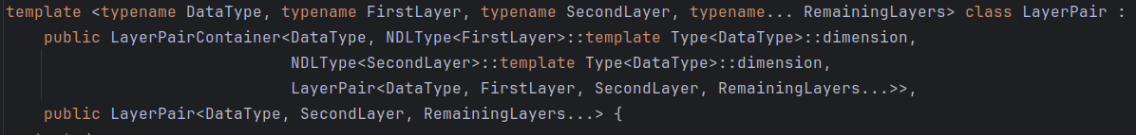**image 3.3.1.4a** the LayerPair class

**image 3.3.1.4b t**he Layer class

The LayerPair class is based on the same idiom of template expansion; as it can be seen, the LayerPairContainer depends on two adjacent layers, so the dimension of the weights, that are 2-dimensional LinearArrays, can be computed.

As mentioned previously, serialization is crucial in a neural network. As the entirety of the network can be obtained from the weights, serialization of the network represents serialization of the weights, therefore the LayerPairContainer class is responsible of this.

The base case of the recursion is more straightforward in this case: the last layer pair receives as parameter a special type of layer that has associated a cost function in addition to the usual parameters.

The generic feedforward and backpropagation functions can be seen in image 3.3.1.5. In the case of the final layer, they are specialized so that feedforward returns the final output of the entire network, while bac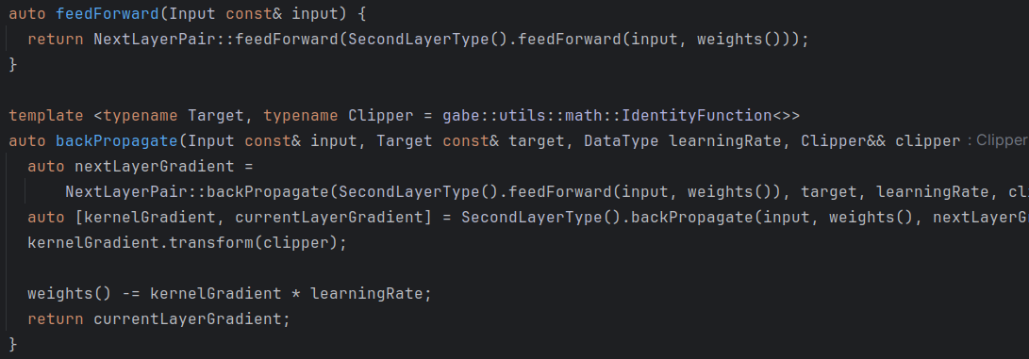kpropagation applies the cost function to compute the corresponding gradients.

**image 3.3.1.5** feedforward and backpropagation

As can be seen, backpropagation is parametrized with two template parameters: the *Target* and the *Clipper* parameter. The reasoning behind *Target* is that although the size of the last layer in our network corresponds to the size of the target vector, layers are only aware of the size of adjacent layers and such cannot know the final output of the network. Although this may seem like a source of errors, the type matching between *Target* and the LinearArray in the final layer is always caught at compile time and the problem can be easily solved. The *Clipper* parameter was introduced in the later stages of development, while trying to fit a more complex model, not a standard neural network. It offers the possibility to provide the network with a gradient-clipping function to prevent exploding gradients.

After completing the implementation of a standard neural network, the last aspect to treat is the addition of convolutional layers to a neural network. Convolutional layers come with more parameters than standard layers, as can be seen in the class definition in image 3.3.1.6

**image 3.3.1.6 t**he ConvolutionalLayer class

The feedforward and backpropagation implementations are no longer as straight forward as in the standard Layer case, and all mathematical computations required have been thoroughly documented [11].

Although the LayerPair implementation of the feedforward and the backpropagation functions is invariant to the underlying Layer implementation, two problems arise: the size of the weights when a convolutional layer is part of a pair and the transition from the last convolutional layer to the first fully connected one. This is known as flattening, as the 3-dimensional shape of the data is compacted into a 1-dimensional vector for further processing in the fully connected layers. The responsibility of flattening the 3D LinearArray between the last convolutional layer and the first fully connected one falls on the LayerPair class. In order to treat this problem in a unifrom manner, corresponding to the LayerPair implementation that already existed, a simple specialization of the LayerPair class was required, as can be seen in image 3.3.1.7

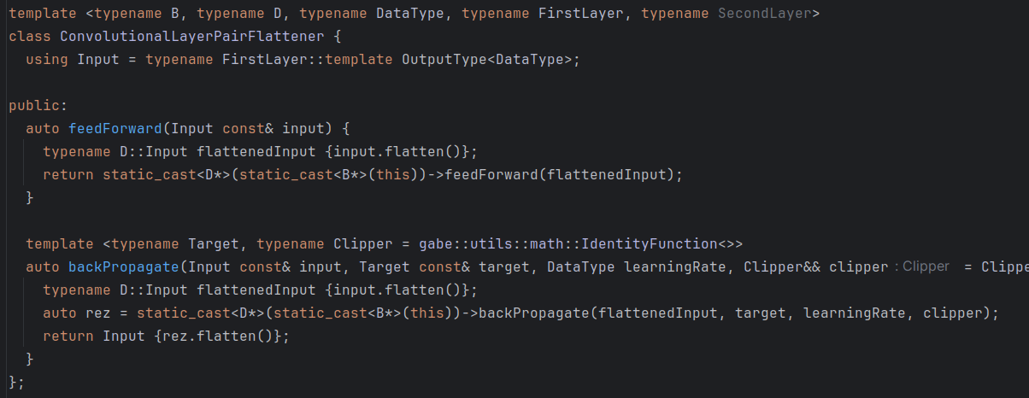**image 3.3.1.7** the LayerPair flattener specialization

As can be seen, this class has two responsabilities: to flatten the input as it goes through the networks, as can be seen in the feedforward step, and to propagate backwards a compatbile LinearArray, in order to conform to the type expected in the previous layer.

Returning to the issue of the weights of the network in the case of convolutional layers: if in the case of fully connected layers, the sizes of adjacent layers dictate the size of the weights between them, when convolutional layers are considered the situation is actually completely reversed. The size of the kernels and the number of kernels in a layer represent the actual weights between that layer and its predecessor, while the relationship between the dimensions of the previous layer combined with the current layer kernel give the shape of the output, namely the layer size.

To better understand this, lets take an example: say we have two fully connected adjacent layers; layer A of size 10 and layer B of size 8. Betwen layers A and B exists a matrix of weights of dimension 8 * 10 = 80 individual weights. The output of this pair is an array of size 8 (or rather 8x1 as we work with 2-dimensional arrays at all times in a simple neural network).

In the second example we have two convolutional layers: layer C that outputs a 10x10x3 image (10x10 image over 3 channels) and layer D that have 5 kernels of size 3x3 (the depth is implicitly equal to 3, the depth of the output from the previous layer). The number of weights is equal to the number of weights in the kernel, meaning 5 * 3 * 3 * 3 = 135 individual weights. Given a stride of 1 for the convolution, the output of the D layer would be of size 10x10x5 (10x10 as the size of the image does not change, 5 as the number of kernels involved in the D layer).

Convolutional neural networks introduce, as mentioned previously, a second type of layers: pooling layers (image 3.3.1.8). They have a considerable number of parameters, just like convolutional layers, and they conform to all the properties specified above, with one exception: pooling layers produce no weights. As the pooling layers act directly on the input, there is no need for a LayerPair between a convolutional layer and a pooling layer to produce any weights.

**image 3.3.1.8** the PoolingLayer class

One last feature was added to the layers before attempting to train the neural network was the InitializationScheme. At first, I was making use of random initialization from the [-1, 1] interval to initialize the weights in all the layers. This way of initialization may be effective in the case of simple neural networks with fully connected layers. However, in the case of CNNs, this is no longer the case. Special initialization schemes, such as He initialization or Xavier initialization are needed to ensure faster convergence of the network. Considering that each layer may need a different initialization, incoporating the possibility to pass a custom initialization scheme to each layer was necessary.

After developing all necessary tools to create a neural network, the last remaining aspect was to aggregate all of them into a class that could easily handle a labeled dataset and backpropagate it through the layers: the NeuralNetwork class (image 3.3.1.9).

**image 3.3.1.9** the NeuralNetwork class

As can be seen in the definition, a NeuralNetwork is simply a wrapper arround a LayerPair that encompasses all the layers. The main feature of this class is found in the backpropagation methods (image 3.3.1.10).

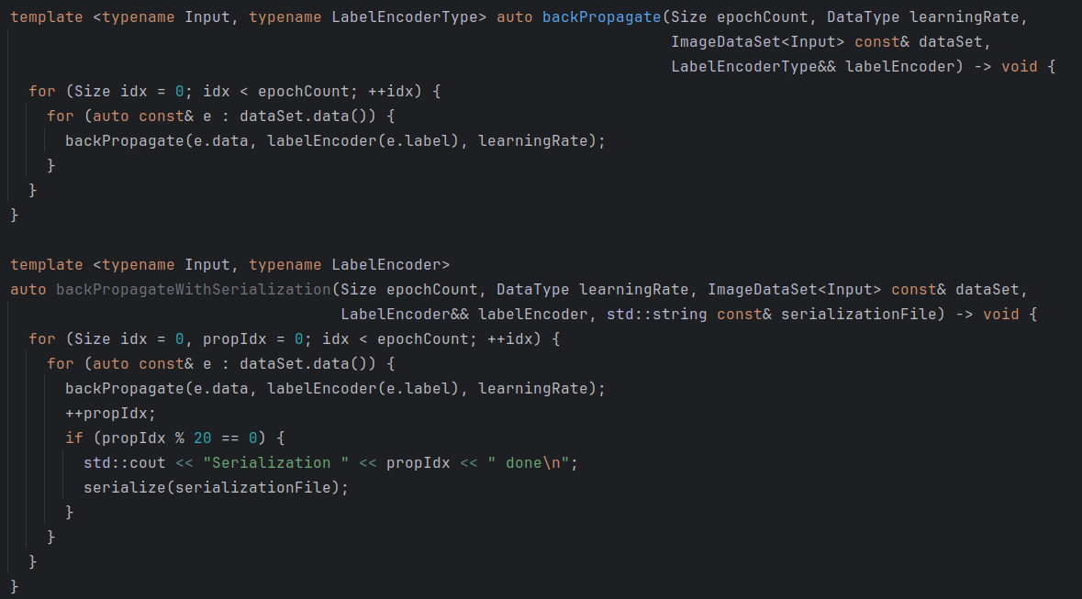**image 3.3.1.10** backpropagation in NeuralNetwork

The serialization aspect in the second method is used to train a model with possible faults in mind; should execution of the code fail or for the entire computing unit to fail, progress shall be saved. Another advantage of using serialization while training is that should divergence of the model occur, the last stable model can be analyzed to determine issues of the model.

LabelEncoding is used in the case of single-value labels to convert them into a form suitable for the network (**e.g.** one hot encoding).

Having the tools necessary to build the YOLO model, the only aspect left to choose were the parameters of the network. The YOLO v1 model made use of GPU computation so the entire model was too expensive to use. Due to this, I chose a network of smaller dimensions that followed the same general directions (image 3.3.1.11).

The first 2 strided convolutional layers used large convolutions to capture relations in bigger regions of the images. The pooling layers were used to reduce dimensionality. The last 4 convolutional layers were used to further process relations between the adjacent pixels. At the end, two fully connected layers were used to predict the final labels. Initialization schemes were chosen accordingly to the structure of the network to ensure convergence.

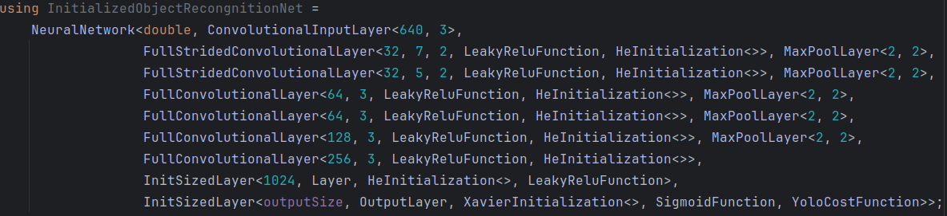**image 3.3.1.11** the final object-regonition convolutional neural network

Having built the network, data had to be gathered in order for the model to train. In order for a YOLO based model to train it needs images labeled with bounding boxes and class labels. Moreover, the amount of data should be quite consistent, otherwise the model mai fail to correctly extrapolate. Luckily, I managed to find a prelabeled data set [13] with over 1200 train images and 185 test images.

The data came in pairs of *(image.jpg, labels.txt)* and the *labels.txt* file consisted of multiple lines, each defining a valid detection for the corresponding image in the form *(class, xCenter, yCenter, width, height).*

Parsing the label files was straightforward, as their structures implies reading each line and converting it to a suitable representation for backpropagation. The jpg images, on the other hand, needed an external library in order to be read; for this purpose I used libjpeg, a raw library for processing jpg files (see image 3.3.1.12).

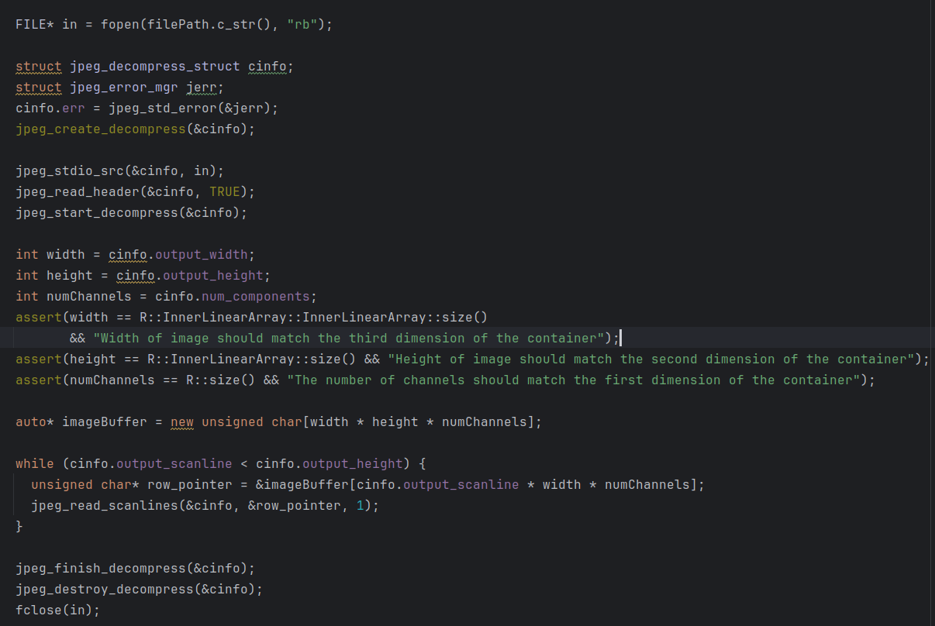**image 3.3.1.12** decompressing a jpg image into an array of bytes

Having labeled and transformed the images into a valid representation for the network, the goal of training the model was the last remaining aspect; the implementation of the training process can be seen in image 3.3.1.13.

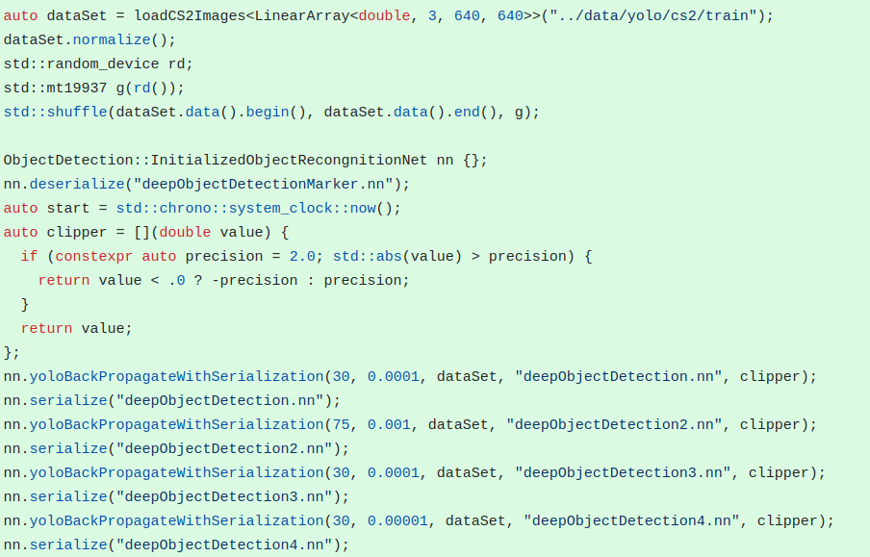**image 3.3.1.13** training the model

The prediction speed of the model was encouraging, given the full CPU bound computation: 80ms/prediction, or about a half of the average reaction speed of a Counter-Strike player. However, the training process posed two problems: the first, and minor one, was the size of the network and the second, critical, one was the divergence of the model.

As can be seen both in the structure of the dataset [13] and in image 3.3.1.11, the target images were of size 640x640 pixels in RGB format. Although multiple layers of maxpooling were used in order to reduce the size of subsequent layers and, implicitly, the number of weights in the network, the final size of the model was quite large: ~3GB or approximately 800.000.000 weights. As mentioned in section 3.0, the desktop used for testing could easily fit this into memory. The problem concerned another aspect: the stack size. As mentioned previously in this section, the entire network relies on the LinearArray class, which in turn relies on the std::arrray class from the C++ standard; and that is a data-structure allocated entirely on the stack. Although this does improve performance, the standard stack size for a Linux executable (without modifications of these parameters prior to execution) is only 8MB. This obviously could not accommodate the memory requirements of the network and produced the SIGSEGV signal on each run due to a Stack Overflow. Without the required experience, this issue eluded me for a couple of days, which in turn slowed down progress of the applications. However, the issue was solved shortly after identifying the problem through a simple increase in the stack size prior to calling the *train* method.

The second issue, meaning the divergence of the model, proved to be irreperable. Due to unknown reasons, the model failed to produce the expected results. The first issue was related to the weights starting to grow too fast. In order to prevent this (a problem known as explodin gradients) from happening, the gradient clipping mechanism present earlier was introduced. Although this did indeed limit the magnitude of the weights, the model remained unstable. This brought up the second issue: Nan (not a number) values. The model used single precision floating points for the weights, but after a number of iterations the weights in the network became undefined (nan).

At first, this only seemed to be a continuation of the first issue; however, analysis of the progress of the weights through iterations showed nothing of this: the weights seemed all stable in an iteration, but after propagating only one more training image, most of them becamse undefined. Having identified the problematic state of the network, I tried to capture a snapshot of it and investigate from there. The problem became obvious once I tried to pass an example image through the network: it only predicted boxes of size 0 and size equal to the entire image size. This was a disastrous result, as it showed that the model was unable to provide any kind of useful information. The first natural idea to solve this was to reduce the learning rate and vary it through iterations; unfortunately, the result stayed the same.

Searching for explanations behind this anomaly were also in vain, as no helpful source of information was found. Seeing that training the model for a certain period of time resulted in this issue, the second idea came to mind: using an intermediate state to see whether it managed to learn any sort of features. However, the number of iterations for which the model didn’t diverge was far too low (about 1500 example could be propagated before divergence), therefore this idea was also a failure.

Having already invested a considerable amount of time into debugging the network, I decided that it was for the best to abandon this momentarily, use an already trained model to detect enemies, develop the remaining aspects of the bot and return to the network after finishing all the components.

That brought me to the second alternative for object detection: the dataset that I used also provided a pretrained model for testing. However, in order to use this model, I needed to use Python with the Roboflow library. This need to use Python introduced a slight issue: as my implementation was in C++, I needed a way to communicate from within my program with a Python script and translate the predictions into a proper format.

The communication between the program and the script was realised through pipes (image 3.3.1.14). The C++ process forks and creates a child process. Before launching the Python script, the standard input and standard output file descriptors are overwritten so that two pipes act as the communication channels between the child and its parent.

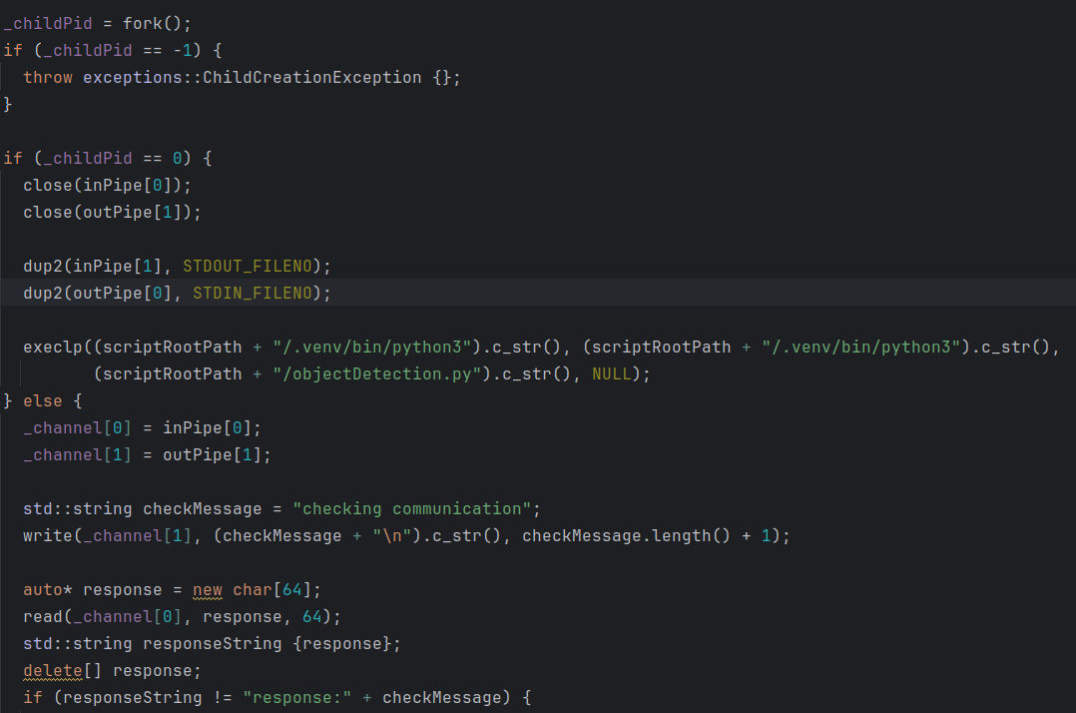**image 3.3.1.14** launching the Python object detection model as a child process

After overwriting the file descriptors, the script (image 3.3.1.15) is launched into execution. The parent would then pass an image as an array of bytes through the pipe and receive the corresponding bounding box predictions (image 3.3.1.16).

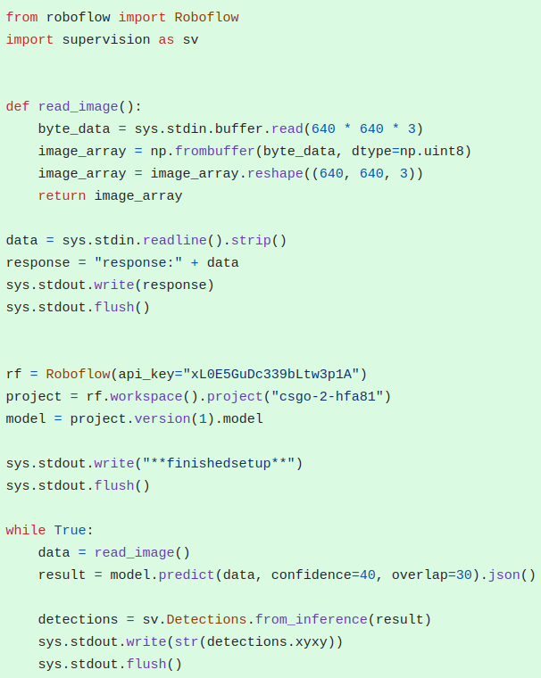**image 3.3.1.15** the object detection Python script

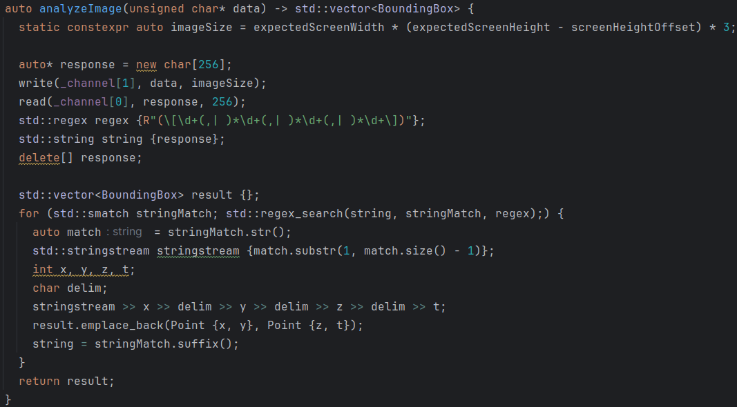**image 3.3.1.16** communication between the C++ program and the Python script through the pipes

As can be seen, the mechanism is quite simple, with the C++ executable sending 640*640*3 bytes of data at a time and the script reading them from the pipe, interepreting it as a 640*640 RGB image, passing it through the model and writing the predictions in the pipe in the following format: [*prediction_1, prediction_2, … prediction_n]*  where each prediction is in the following format: *[x y w h].*

Even though the precision of the predictions was remarkable, the speed proved to be absolutely unacceptable: ~800ms/prediction, meaning more than 5 times slower than the average player’s reaction speed. This performance was in clear contradiction with objective 1 from section 3.1, so the results still needed improvement.

As the model provided was from an external source, I had no control whatsoever over the source code. Any effort in this direction would be of no result. This setback guided me to the third, and final, variant of the object detection mechanism: training a YOLO model with Ultralytics.

Having already analyzed and benchmarked the performance of a YOLO model, it became clear that using this kind of object detection was the right choice. My lack of experience in the Machine Learning domain was the main reason behind the failure of the first idea. The second idea helped me create a communication channel from the executable to a Python script, an idea that could be tailored around any other model, not necessarily the Roboflow one. With these in mind, I used the Ultralytics library to train a YOLOv8 mini model with the already collected data fo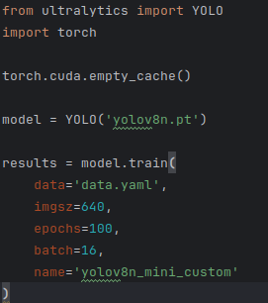r predictions (image 3.3.1.17).

**image 3.3.3.17** training a YOLOv8 model

As the performance needed to be as high as possible, I also used CUDA to enhance computation speed through the usage of the GPU. And the results proved to be well above expectations: a precision comparable, if not even better, to the Roboflow model and a speed of 20ms/predictions. The overhead introduced with the communication through the pipes was well compensated by the remarkable speed of the model.

The structure of the script in image 3.3.1.15 suffered only 2 modifications: first of all, the Roboflow model was replaced with a locally trained YOLO model; and second of all, the array of data was passed in RGB format; however, due to backwards compatibility reasons from CV2, the model was expecting BGR format; this was solved with a simple rearangement of the bytes.

Having obtained a model that fits both the requirement for precision and speed, the enemy-detection component was finalized and development could be focused on the next feature.

3.3.2 Position reading

The second aspect of concern was gathering real-time information about the position and the camera orientation of the bot. Naturally, as a 3D shooter, the position and orientation are tuples of 3 values: *(x, y, z).* Naturally, of concern are usually the *x* and *y* coordinates both for the position and the orientation. The *z* coordinate for the position may interest us under certain circumstances, as the position may very based on the elevation. The *z* component of the angle however is of no use, as Counter-Strike has no mechanism of rolling the camera in that axis.

As stated in section 3.2, no standard source of information from the game provides any of the required information. However, the aformentioned developer console proves to be the solution to this issue. One of the commands available in the developer console is the *cl_showpos 1* command. As can be anticipated from the syntax, this command sets a flag of the engine to the *true* value, which in turn prompts it to display information about player’s position, orientation and velocity in the UI (image 3.3.2.1).

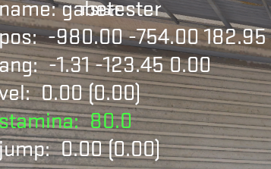**image 3.3.2.1** the output in the UI of the *cl_showpos 1* command

In image 3.3.2.1 two problems can already be seen: firstly, from the first row, corresponding to the *name* section, we can see tha the UI does not accommodate the new elements in any way, as the name of the character overlaps with the already existing UI; secondly, the font colour is unmodifiable, meaning that the text may become unreadable on a lighter background. The first issue proved to not actually be a problem, as that region of the screen is unused by the standard UI, and only the name slightly overlaps, an aspect of no concern to the bot. The second issue, however, would eventually pose more problems, as we shall see.

Two other aspects worth emphasizing are that the size of the digits is approximately the same, regardless of the digit (or about 15x25 pixels in a standard 1920x1080 resolution) and that the position of the displayed information is static. This second piece of information led me to my first idea: capturing the corresponding region of the screen, passing it through an algorithm for digit recognition and reconstructing the final numbers.

The first problem with this approach is the following: although digit recognition can be done, is number reassembling just as facile. And here comes the third piece of information that the format of the output provides us with: as can be seen from the *x* component of the position (value -980.00), regardless of the value of the fraction part, there are always two digits after the decimal point. Although the value before the decimal point may very in length (the map ranges to values lower than 10.000 in module), each component contains a decimal point and two digits after. This means that with the digits, possible minuses and decimal points correctly identified, the number reconstruction process was straightforward.

The first idea that came to mind was to gather a set of images, label them and use a neural network (as the support for such an idea already existed due to the attempt in enemy recognition) to train a model that would predict, given a 15x25 RGB image, whether the image represented a digit, a minus, a dot or none of this. After training the model, I would use it with a sliding a window of size 15x25 over two images of size 245x25 (an approximate to be able and capture the whole position and angle regardless of the value of the coordinates) that correspond to the two set of coordinates and, after this, get the symbols and reconstruct the numbers. Even though the idea seemed reasonable, it had two issues: there existed no dataset that I could use, so I would have to gather the images and label them, and it was out of proportion; the size and font of the digits remained invariant to any factor. Training a whole network would be meaningless, as a simple pattern matching against precomputed templates would be enough.

Therefore, I refined the idea; the sliding window described above was in order; however, instead of training a whole network, I enhanced 3 images (image 3.3.2.2a, 3.3.2.2b, 3.3.2.2c) in order to use only the full-white pixels for the templates. I created label files for these images, containg the given label of the template and its starting point on the X axis (**e.g.** the 5 in image 3.3.2.2.a starts at pixel 25).

   
**images 3.3.2.2a, 3.3.2.2b, 3.3.2.2c** enhanced images for the template digits

By only using the full-white pixels for the digits, I could simply modify the templates by editing the training images, in order to correct possible errors.

The templates were represented through 2-dimensional LinearArrays that had the following property: the white pixels would correspond to positive values and the non-white pixels to negative ones and the sum of all the values in the matrix would be 0 (image 3.3.2.3). The *loadCoordDigitsImages* makes use of the jpg loading mechanism used for the loading images for the first enemy-detection idea.

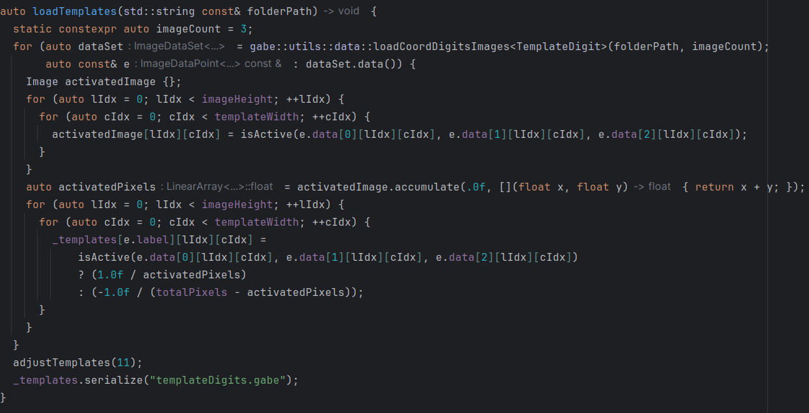**image 3.3.2.3** loading templates based on the training images

After that, I would convolve each template over the current region given by the sliding window (image 3.3.2.4). As the white pixels have larger values (255*3 a perfectly white pixel), the convolution between a template and a correct match would produce a highly positive value. Some convolutions may produce false positives, as a match between a 1 and the left-margin of a 6 would produce a positive value. For this reason, I applied two corrections: first, the result of the convolution was compared against a threshold; this way, a partial matching would no longer be a false positive; second, I ensured that predictions start as close as possible to the first real digit (the sliding window would, as much as possible, match a digit/minus from the beginning) and then, based on the detected symbol, the sliding window would “jump” a number of pixels. This resulted in a much better precision.

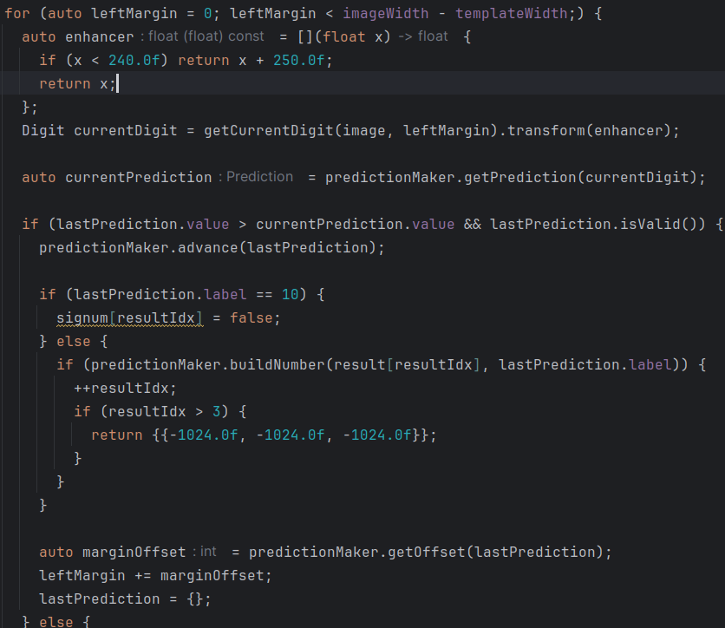**image 3.3.2.4** digit detection through convolutions

Although the results of the prediction were remarkable, with perfect identification of the coordinates, in cases such as images 3.3.2.5a and 3.3.2.5b the issue related presented earlier, regarding the unmodifiable font, can be seen in image 3.3.2.5c.







**images 3.3.2.5a, 3.3.2.5b, 3.3.2.5c** two correctly indentified examples and a fully misclassified one

Due to the difference in lighting in certain orientations and the background, certain images were completely unreadable for the algorithm. Moreover, even slight regions of powerful lighting would heavily damage the accuracy of the algorithm.

I attempted to use an error-correction on the prediction, based on the last known position; however, the chosen map, de_dust2, proved to have a considerable number of places with powerful lighting; this resulted in abandoning this idea for position reading, as it became completely unreliable.

The second idea, which was only a hopeful attempt, without great probability of success, was to use a memory reading application in order to find the current player position. I imagined that, despite the numerous mechanisms implemented by Valve against such cheating, the current player position was a piece of information the did not provide any considerable advantage; therefore, it might be readable without any protection.

The interface for this process was GameConqueror (image 3.3.2.6), a memory scanning program with a UI that allowed searching for values and intervals in order to indentify map-locations were the searched information may reside. Unfortunately, the very first attempt resulted in a failure; although I managed to locate certain addresses coresponding to the values of the current position in the X axis (I used the values from the *cl_shopos 1* as target), moving the character even a bit and searching for the new value provided no matches. This attempt too proved to yield no results.

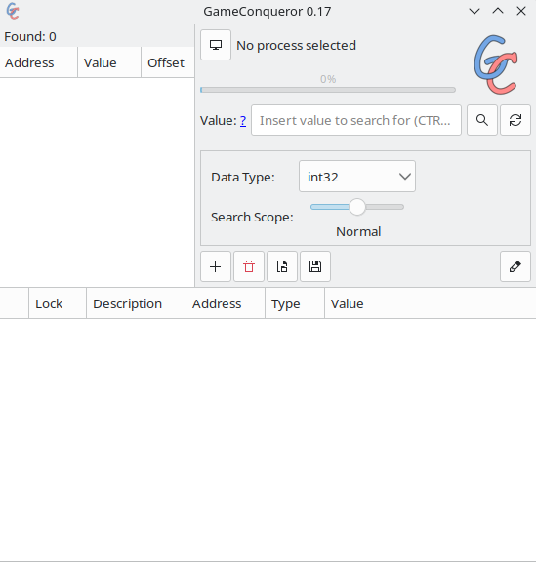**image 3.3.2.6** the GameConqueror interface for memory reading

Although the second idea made no use of the first one, the third, and final, solution did. Although the *cl_showpos 1* command proved to be of little help, a related command was *getpos.* This command did not yield any result to the UI; on the other hand, it printed the current player position and orientation in the developer console; this meant no more processing of information. The only issue was that the contents of the developer console were unavailable to my executable, thereafter a workaround was required.

Counter-Strike allows, as any executable, passing of certain command line options at launching [14]. This is done through special options specified to Steam for the chosen game (image 3.3.2.7). Two of these options, 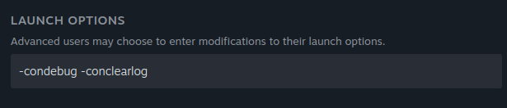that can be seen in image 3.3.2.7, were of interest: *condebug* that “Logs all console output into the console.log text file.” and *conclearlog* that “Clears the console.log text file on start. Only works if -condebug set.” With these two flags enabled, I could continuously request the current position with the *getpos* command and process the *console.log* file in order to get the result of the command. Luckily, the output of the getpos had a very convenient format: *setpos pos_x pos_y pos_z setang ang_x ang_y ang_z* where the *pos_x, pos_y* and *pos_z* values correspond to the actual coordinates and *ang_x, ang_y* and *ang_z* correspond to the orientation.

**image 3.3.2.7** passing launch options to Counter-Strike

Issuing a getpos command by typing it repeatedly would have been cumbersome; a better alternative was available: by creating a keybind to the *getpos* command with the developer console and binding it to a single key (‘p’ in this case) pressing p would result in a *getpos* command being issued.

As Counter-Strike logs a considerable amount of information to the console, the file needed to be constantly parsed in order for the position and orientation to be updated in real-time. For this reason, a separate thread is responsible for constantly parsing the file and updating the necessary information in a multithread-safe memory region (image 3.3.2.8)

There a number of aspects to note here:

1. the path to the *console.log* file depends on the location of Counter-Strike on the user machine; this requires the user to pass the path to the Counter-Strike root folder at compilation (see section 4)
2. constantly reading the file proved to block the thread; for unknown reasons the only way for the thread to stay up-to-date with the contents of the file was to close the file upon reading EOF and reopen it, with the mention that the current file position was remembered in order to prevent rereading of the entire file.
3. in line 49 in image 3.3.2.8 a certain synchronization with another thread can be seen; this will be discussed in section 3.4
4. the thread directly updates the memory region with the new position and orientation; although this does imply tight-coupling between the PositionReader component and another, yet to be described component, this choice was made for efficiency reasons.

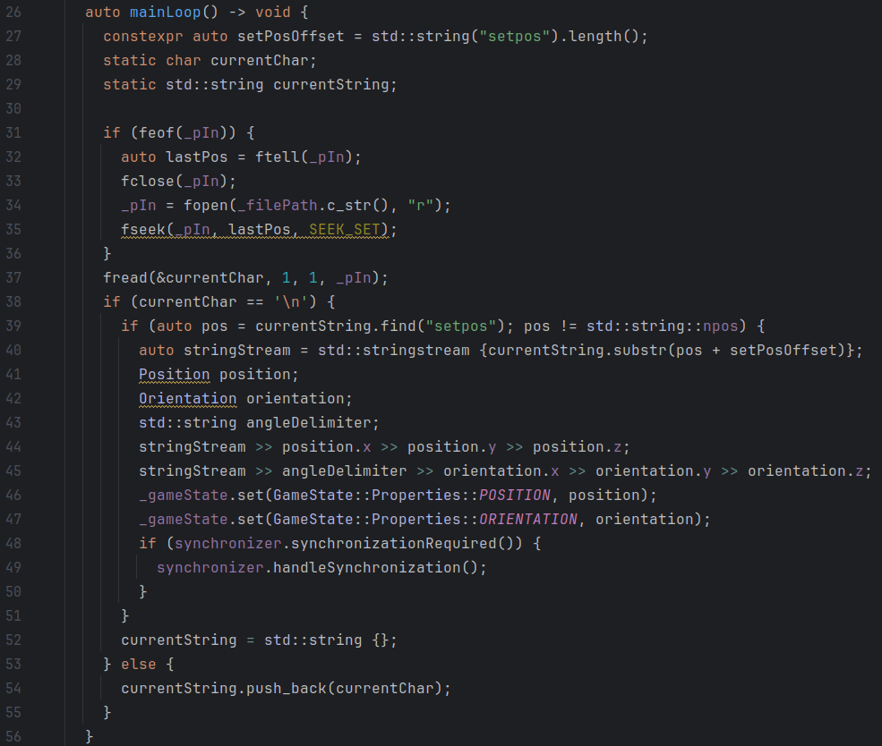**image 3.3.2.8** parsing the *console.log* file and updating the given memory region

With a fully functional position reading mechanism in place, only one information-gathering component needed development: the Game State Integration communication component.

3.3.3 Game State Integration communication

As mentioned in section 3.2, Game State Integration exposes real time information about the game, and this happens by sending HTTP requests to a user-defined server. The server is defined by using a *cfg*  configuration file.

Configuration files are files that Counter-Strike automatically runs at startup; in order for Game State Integration to be used, a configuration file named “gamestate_integration_yourservicenamehere.cfg” must be placed under the game/csgo/cfg directory; in my case I used *gamestate_integration_gabe.cfg.*

The configuration file (image 3.3.3.1) specifies two aspects: the server where the HTTP requests that carry the expected information and the information to be sent. The data is sent in a JSON format analyzed thoroug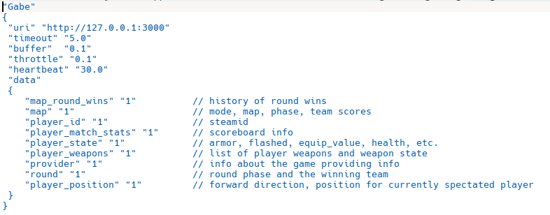hly in [4].

**image 3.3.3.1** the game state integration configuration fileimage 3.3.3.2a and 3.3.3.2b

The first feature to be implemented was, naturally, the server; for this, I created a simple server using C style sockets and threads (images 3.3.3.2a, 3.3.3.2b). Each request would generate a new thread that would run a predefined function (image 3.3.3.4). Following this, I needed had to parse the incoming text as a HTTP request (implementation in image 3.3.3.3).

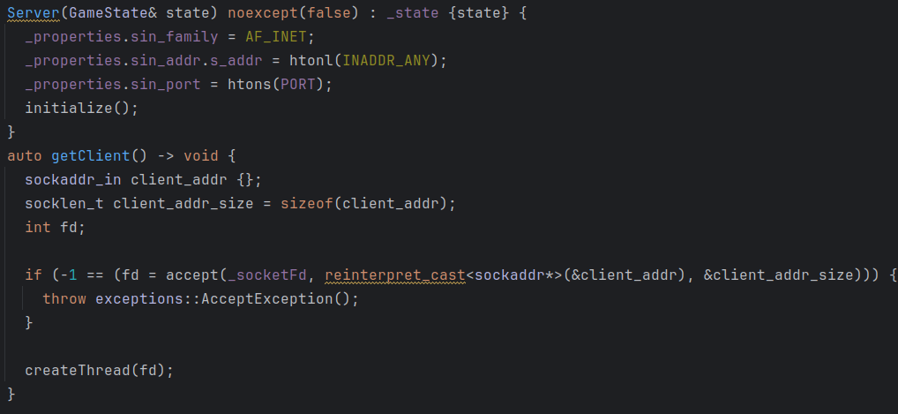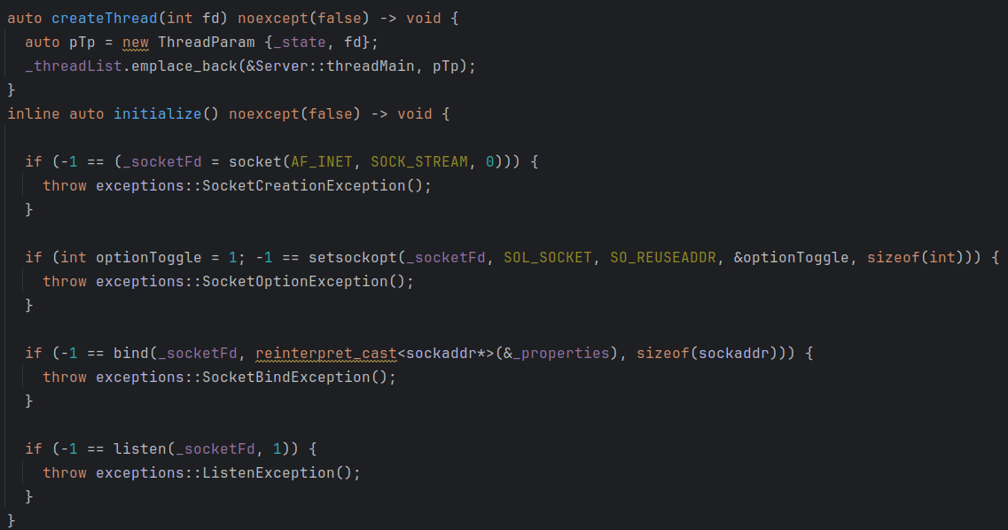  
**images 3.3.3.2a and 3.3.3.2b** a C-style server to accept HTTP requests

The request headers served no purpose; the body was the main object of interest. As stated, the body was in JSON format and for parsing this I used the CDS library [8] to convert the data in an internal representation.

The same idea as in the position reading component was used; direct updates of the corresponding memory with the newly aquired information. As can be seen in image 3.3.3.4, each thread contains a reference to the target object, an object whose update is multithread-safe, and updates it based on the JSON information.

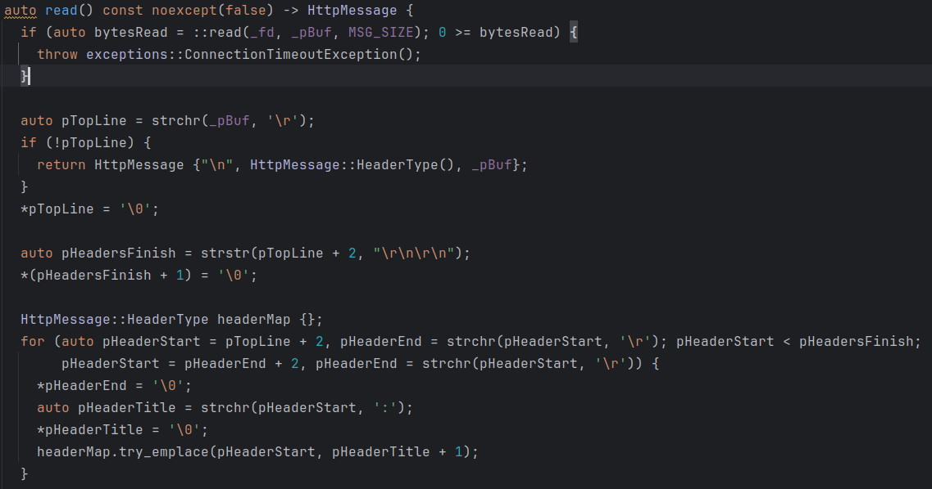**image 3.3.3.3** HTTP format parsing

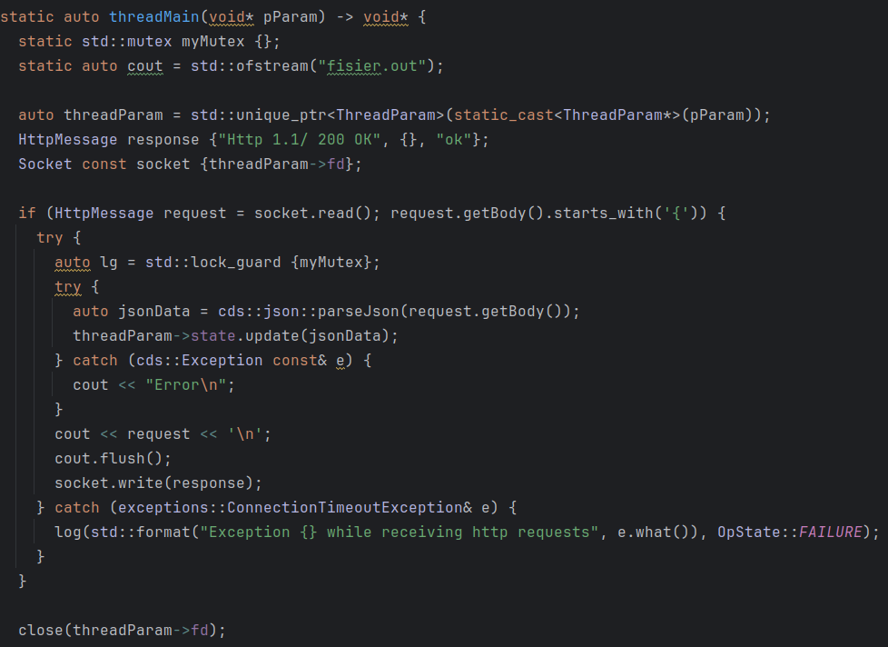**image 3.3.3.4** the thread function executed upon receiving a new request

As the server has to constantly wait for new requests, to ensure real-time updates of the game state, a separate thread is responsible for receiving the request and launching other threads in execution to parse the data. This follows the same paradigm as the position reading component and, as we shall see in section 3.4, they belong to the same class hierarchy.

Turning back to the Game State Integration issue; we have a way of extracting the information; however, we still haven’t analyzed the payload of the HTTP reqeust to see the available information.

As it is used in major tournaments, the payload contains information related to the number of kills, the score of the player and other such aspects of no interest to our bot. Of interest, on the other hand, are the following:

1. information about the player state in the *player* element: armor, the presence of a helmet, the money and the health; the first three aspects are of interest during the buying phase; the last one could be used to alter the behaviour of the bot
2. information about the inventory of the player: the payload contains a JSON object *weapons* that fully describes the inventory of the player through multiple elements named *weapon_idx*. Each *weapon_idx* contains infomration such as the weapon name, weapon ammo, weapon state (whether it is reloading or not / whether it is the active weapon or not). A slight issue with the *weapons* element is that it is not consistent; the absence of a weapon (say rifle) produces a reindexation of the elements; for this reason the weapon name is crucial for a proper updated of the inventory
3. information about the state of the round in the *round* element; whether the current phase is buying, running or ending. Information about the bomb (if it is planted or defused) also appears in this element after the bomb has been planted; prior to that moment, no information about the bomb is sent.

Example of all the payloads are in images 3.3.3.5a-c.

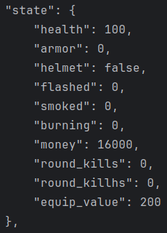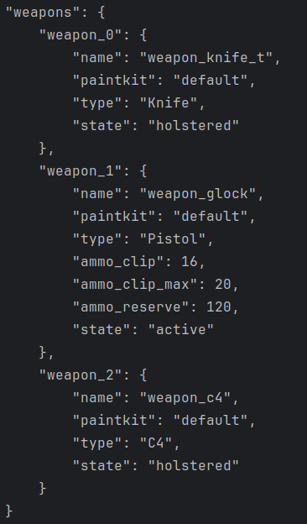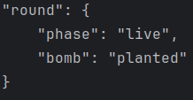**images 3.3.3.5a-c** JSON payload examples

In order to reflect the information received from Game State Integration, I mirrored the three elements into three classes to reflect this separation: the Inventory, Player and Round classes, all of them specializing the base JsonUpdatable class (image 3.3.3.6) that makes use of static polymorphism mechanism in C++, as the behaviour is fully known at compile time.

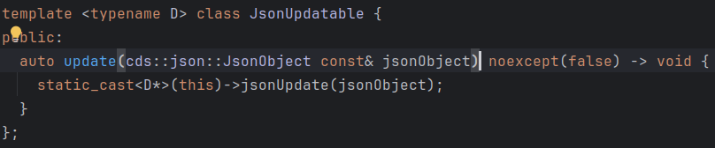**image 3.3.3.6** the Json updatable class

The members of the three classes mentioned above can be seen in images 3.3.3.7a-c

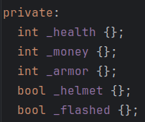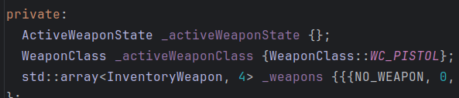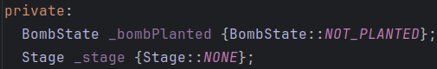

**images 3.3.3.7a-c** members of the Player, Inventory and Round classes

As can be seen, the members of the classes mimic the information available from GSI. The only member that needs special attention is *_weapons* from the Inventory class. As mentioned previously, the *weapons* element in the payload is an unordered collection of all the weapons available to the player; the inventory however has only the knife weapon that is always present; the main weapon, secondary weapon and plantable bomb may be droped or acquired if the item is missing from the inventory (Counter-Strike also has grenades as throwable items but they are not used by the bot, so their presence in the payload is ignored).

Another special case is the bomb state: as mentioned the payload simply does not contain any information regarding the bomb if it is not planted. In order to maintain a consistent state of the bomb, the existence of the key *bomb* must be checked under the *round* item from the main JSON; the absence of such a key represents the bomb state as not being planted (see image 3.3.3.8 for the implementation).

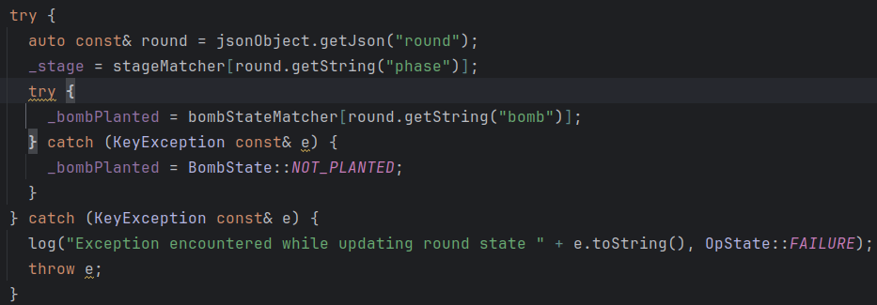

**image 3.3.3.8** updating the round and bomb state given a JSON; the *bomb* key may be absent, resulting in the bomb state modifying to not_planted

With this, the analysis of the Game State Integration component is finished; and this concludes the three components used for analyzing the environment and aggregating information.

The last subsection will focus on a different, yet essential, component: the environment interaction part.

3.3.4 Window Controller

As stated in the beginning of this paper (section 3.0), X11 is required as the display server in order for the application to function. The reason behind this is that the entire interaction between my application and a running Counter-Strike program is done through Xlib library that encompasses all the features of X11 in an API.

The communication between X11 and another window is realised through events; raw X11 events were cumbersome, therefore I used a more standardized version: the Xtest header of the Xlib, a header that provides *FakeEvents* that are easier to configure and send over to X11 for processing.

In order to be able and use Xlib to send an event to a specific window, there is only one requirement: the window ID. This, unfortunately, cannot be obtained with Xlib and another mechanism is required. A non-standard Linux command is needed, *xwininfo*. This command parses and prints the entire window tree of X11; after that a simple search through the result for the name of the window (“Counter-Strike 2” in this case) yields the target id. In order to accomplish this, a simple bash script (image 3.3.4.1a) was used, ran from within my application (image 3.3.4.1b) and so the required id is now obtained.

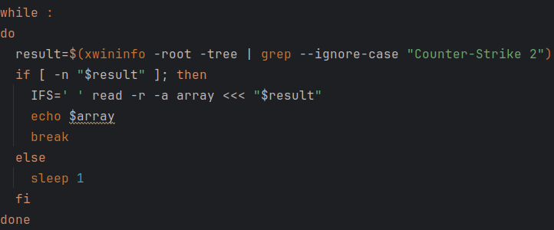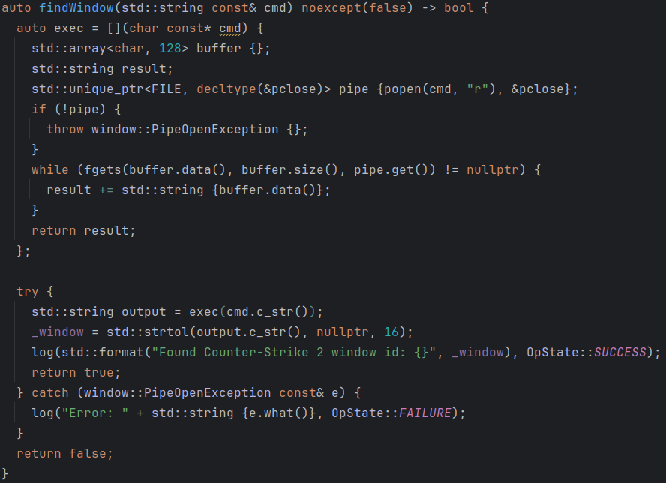**images 3.3.4.1a** and **3.3.1.4b**: the two components for obtaining the X11 window id of Counter-Strike

Having the id, issuing a new event is trivial: a connection to the X11 server must be opened with *XOpenDisplay* and all events must have both the window id and the obtained display as parameters; the other parameters are event dependent. Opening a new connection is not required if one already exists, therefore the same connection shall be used throught the execution of the program.

In order to create a stable design, the task of passing events to X11 shall only fall on one class: the WindowController. This class shall be responsible of the connection and communication with the X11 server. As the X11 events depend on this communication, every event that is to be sent from my program shall first go through the WindowController class. To facilitate the use of the available resources and ensure that no event is missed, the class shall offer a queue for other components of the application to post events that are to be redirected to the X11 server.

Passing raw X events to the WindowController is not feasible, mainly due to engineering reasons: Xevents are represented through function calls of different signatures, meaning that there is no common denominator between them. To make the design as modular as possible, I used the Composite design pattern to define a hierarchy based on the Event class (image 3.3.4.2). The composition comes from the following idea: certain events are basic interactions with the application: mouse clicking, mouse movement, etc. Based on those, more complex events, that for a real player seem like only one interaction, represent compositions between these basic events.

The base Event class acts as an interface, providing only one method: *solve(Diplsay* display, Window window)*; This method reflects the relationship to the WindowController class, as it requires both a X11 connection, the *display* parameter, and a valid window id, the *window* parameter.

As can be seen from the UML diagram, the primitive events are related to key pressing, mouse moving and mouse clicking. Other events compose one or more of these events to produce more complex results such as a spray4 effect or a tap7. Some events represent more complex mechanisms, such as buying new weapons or armour, that needed to be fully encapsulated in a single event, and the motivation shall be described in section 3.4.

An important aspect to note about Events is that they represent bottlenecks to our application; the reasons behind this are that, first of all, in order for our bot to have a human-like behaviour, the speed of its aim must be within reasonable parameters. This means that, although a detection is successful, aiming directly to the enemy without any delay is totally inhumane. And second of all, the speed at which a window is able to process continuous inputs is far less than the computation capabilities of an executable. For these reasons, delays must be introduced in the process of treating Events.

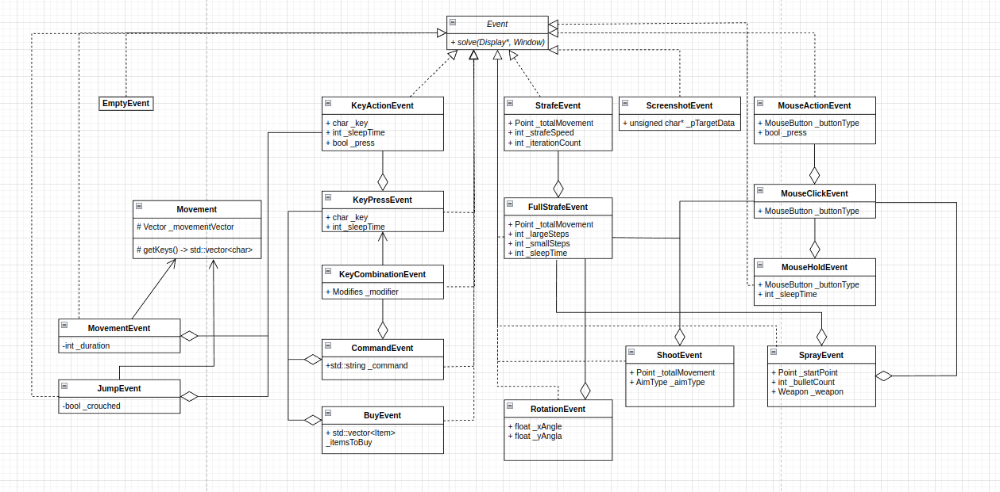**image 3.3.4.2** the hierarchy of Events

Having concluded the digression about the Event class hierarchy, we return to the WindowController class. The behaviour of the class is straightforward: expose the aformentioned queue and process events as they come by providing the connection and the window id to the events. Two more aspects, however, need to be mentioned about this class.

First of all, we have seen that events represent bottlenecks; to prevent computation from being slowed down too heavily, the WindowController class shall follow the multithread model of the PositionReader and Game State Integration communication classes. The WindowController class was, actually, in the development process, the first class whose responsibility is placed in a separate thread. The other two classes, described earlier in this paper, were only later placed under this idiom. For this reason, another class, posing this behaviour, was introduced to encapsulate the responsibility of a multithreaded class: the Runnable class (image 3.3.4.3). This class makes use of the static polymorphism mechanism of C++ and has two functions: to ease the creation of creating a new thread of execution and to allow graceful termination through the _*stopped* member and *stop* method.

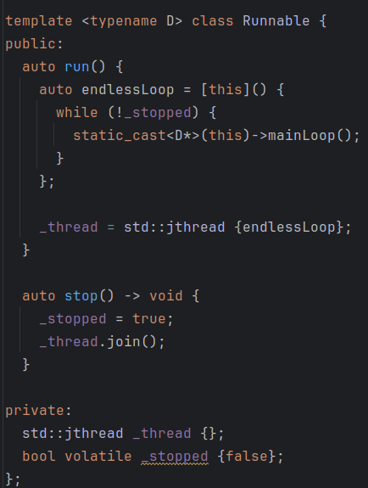**image 3.3.4.3** the Runnable class

Second of all, in a multithread application, synchronization mechanisms are a necessity. As we have seen in section 3.3.2, the PositionReader class presented a synchronization mechanism (image 3.3.4.4) that we are now going to describe. The idea behind the synchronization is based on a mechanism similar to a barrier: it ensures that given two threads that share a Synchronizer, one can wait for the other to reach a certain point in its execution. By calling the *requestSynchronization* method, the synchronizer thread suspends its execution until the “synchronizee” reaches a synchronization point in its execution. Image 3.3.2.8 shows such a synchronization point: having parsed a new set of coordinates, the “sychronizee” is ready to signal the sleeping thread that it can resume execution (in section 3.4 we shall see why this is the chosen synchronizaiton point). Synchronization uses a simple mutex and a condition_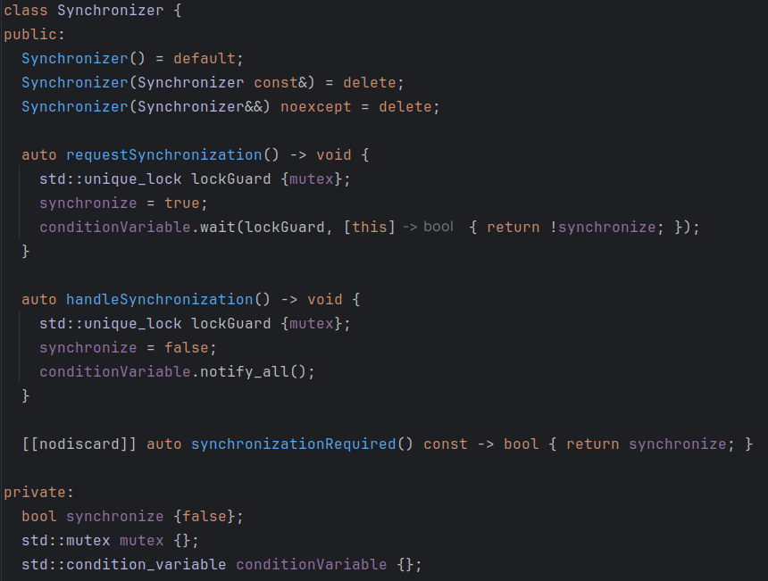variable to prevent busy waiting.

**image 3.3.4.4** the Synchornizer class

The sychronization mechanism described above is also present in the WindowController class (image 3.3.4.5), but this aspect, too, shall be analyzed in section 3.4 as the entire context is needed to understand the synchronization points.

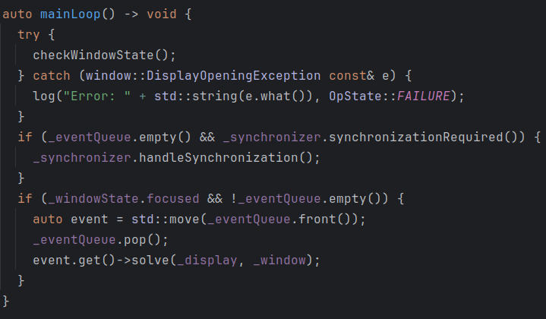**image 3.3.4.5** the main loop of WindowController

The last aspect worth mentioning about Window Controller is that it also maintains an internal state of the windows focus: if the target windows looses focus, events are no longer treated; this was introduced to prevent keyboard and mouse events to be continuously sent by the X11 server and have a simple mechanism in place for pausing the application.

This way the analysis of the main components is concluded; following this, the next section shall describe the aggregation process of these components and the main class responsible for interacting with them.

3.4 The bot engine

This section describes how the previously analyzed components come together to deliver the end-product, the Counter-Strike bot.

3.4.1 The GameState

The first step in aggregating the components of the bot was to create a container class that encapsulates all the available information. This class was named suggestively GameState (image 3.4.1.1 shows the members of the class).

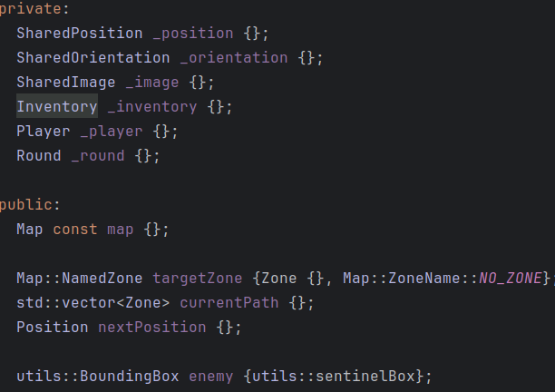**image 3.4.1.1** the GameState class members

The *_position* and _o*rientation* members reflect the contents provided by the PositionReader component, the *_inventory, _player* and *_round* members are linked to the Game State Integration communication component and the *enemy* member is obtained from the ObjectRecognition class.

The other members reflect the following information:

* *_image*: the current image obtained from the ScreenshotEvent that shows the current screen; it is a 1920x1080 RGB image
* *map*: an internal representation of the de_dust2 map; a deeper analysis is made in the next subsection
* *targetZone, currentPath, nextPosition*: all of these members are computed by the engine and dictate the movement of the bot

This class, as mentioned in the beginning, is a simple aggregator of all the information. It is used by the supervisor class (Engine) to provide a communication mechanism between the various components.

The only aspect worth mentioning is that the type of the position, image and orientation members has the prefix “Shared”. This reflects the fact that due to the importance of these values, reads and updates of the said members is protected through a lock, therefore intermediate values are not possible to obtain and information is always accurate.

3.4.2 The Map

As mentioned in section 3.1, the game provides no information about the map by any means. However, by creating an internal representation based on my personal experience and knowledge of the game, the player position can be used to identify the current map zone. Therefore, I mapped the A-side and middle side of the de_dust2 map by using Zones (image 3.4.2.1).

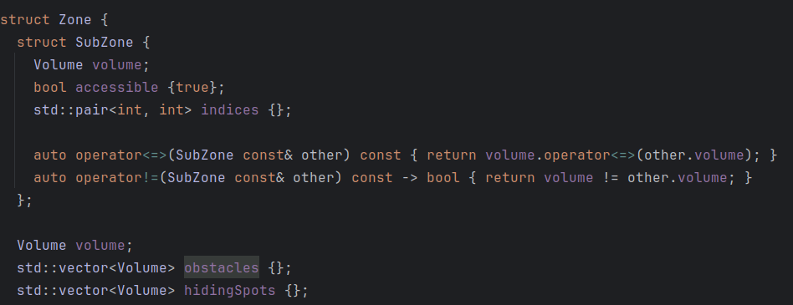**image 3.4.2.1** the Zone class used to map de_dust2 in an internal representation

Each zone is described using a Volume, where a Volume is specified in 3 dimensions using two opposite corners, making ever zone a rectangle when projected to the XoY plane. As we shall see, the Z axis will not be of much interest to us as the bot does not make use of the elevation in the current implementation. As the information about the obstacles is also unavailable, they were also mapped, still as volumes. The last member, *hidingSpots* refers to subzones within the zone that represent points of camping9 for the bot after planting the bomb. The behaviour and use of the SubZone class will be analyzed later, in the movement segment of the engine.

In order to ease the access to the Zones, each zone was assigned a name (image 3.4.2.2 shows all the mapped zones); this aspect was crucial, as my personal knowledge makes use of the map names to identify obstacles and adjacent zones.

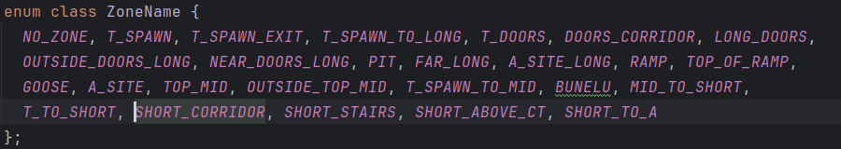**image 3.4.2.2** the name of the mapped zones

Another element of the Map class are the transitions. Transitions (image 3.4.2.3) are the basis for constructing a Directed Graph with the Zones representing nodes and the Transitions representing edges. The graph must be directed, since a transition from zone A to zone B does not imply that from zone B there exists a direct movement back to A. Using this graph, the bot can determine the path required to reach a certain zone based on his current zone.

The *movement* component of a transition represents whether or not a special action is required to transition from one zone to the other (jumping, crouching) while the *transitionArea* member is used to specify whether transition between two zones must happen through a specific area; however, by default, the transition between two adjacent volumes can happen by passing through the common edge of the two volumes.

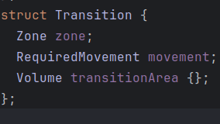**image 3.4.2.3** the Transition class with the Map

As stated in requirement 3.1.3, the bot needs to be able and predict possible camping spots to increase his chance of eliminating the enemy. This aspect was also mapped by hand, as the camping spots remain, most of the time, unchanged.

Having all the elements required to describe the map, I used the *cl_shopos 1* command to identify the borders of each zone, map the obstacles and the zones where enemies may camp and completed transcribing the de_dust2 map into a favorable format (image 3.4.2.4).

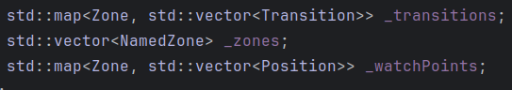**image 3.4.2.4** members of the Map class that describe the zones, transitions and enemy camp spots by zone

The Map class was defined to provide ease of access, such that there is direct access from a ZoneName to the corresponding zone and from a Zone to its neighbouring regions. As can be seen in the type of the *_transitions* member, the map Transitions do not use the zone name; as the zone names were only used for fast identification by myself, holding such information twice in the class would be redundant.

3.4.3 The Decision Trees

Decision making during a match involves a number of decisions being taken by the player every second: where to move next, where to aim, whether to shoot or not, whether to plant the bomb. All of these decisions are made, dependent on on another: moving at shooting at the same time is not a good idea, as the aim becomes flawed during movement.

In order to replicate this behaviour, the bot shall make use of DecisionTrees to make decisions. DecisionTrees are data structures that take into consideration the current GameState, weigh the available options, and produce a decision. In the context of our application, a decision is represented by an Event, as this reflects an in-game action of the bot. Therefore, every DecisionTree is continuously evaluated and a corresponding Event is generated. In truth, some DecisionTrees do not actually produce an event, as they only update the GameState and other intermediate data; however, for the uniformity of the implementation, the EmptyEvent is used as the output of such a tree.

Each DecisionTree will be represented through decision nodes; an inner node of the tree shall execute its corresponding task and given the weights associated with each of its children, choose one of them to activate. Terminal nodes of a tree are the ones that produce the final decisions based on their particular behaviour and the current game state. A flowchart of the entire DecisionTree structure can be seen in image 3.4.3.1.

Two more decision trees exist, however they will be analyzed in particular because their behaviour is particular.

As can be seen from the diagram, certain trees make decisions solely on the current game state (MovementTree), while others also have a probabilistic aspect, choosing the child to activate based on the weight assigned (EnemyDetection tree).

An important aspect is the order of evaluation of the trees: as can be seen, the EnemyDetection tree follows directly from the ImageCapturingTree. This feature is crucial, as it ensures the lowest delay between capturing the screen and running the algorithm of enemy detection.

Every tree also has an associated *postEvaluation* function that is called after the corresponding Event has been generated and passed on.

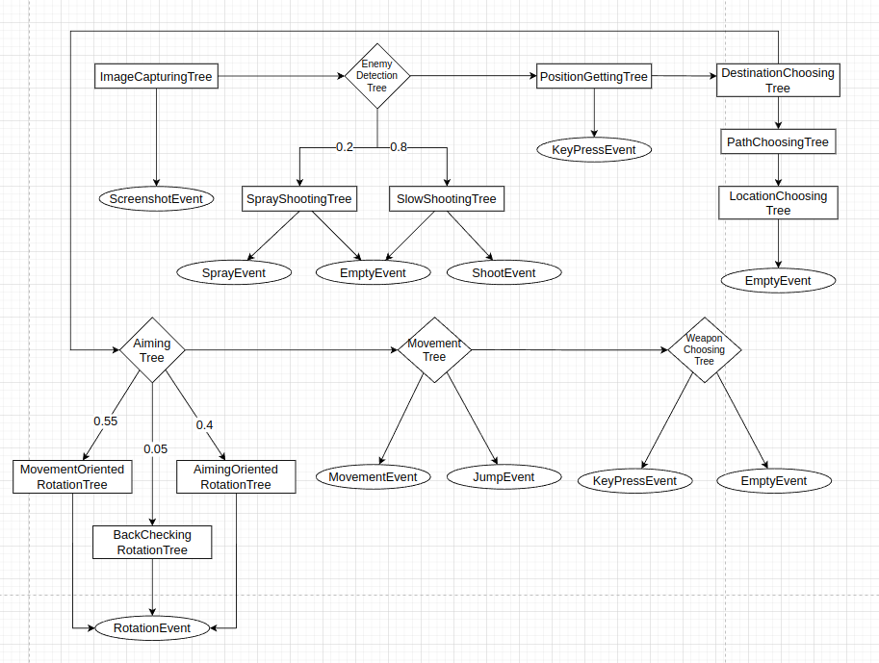**image 3.4.3.1** flowchart of the decision trees

The behaviour of each tree and its children is analyzed below:

* ImageCapturingTree: this tree exists simply to pass a ScreenShotEvent and capture the current screen; an important feature is that the *postEvaluation* function requires a synchronization with the WindowController. As we shall see, the entire tree evaluation is done on a single thread, and such a synchronization implies that before continuing with the other trees, the ScreenShotEvent must be produced to ensure an accurate image is currently in the GameState
* EnemyDetectionTree: this tree calls the ObjectDetection component and updates the _*enemy* member of the GameState to reflect presence or absence of an enemy on the screen. The two children only get evaluated if an enemy is present; otherwise, they directly produce an EmptyEvent without evaluation
  + SprayShootingTree: based on the current weapon and the remaining bullets in the active weapon, it configures and produces a SprayEvent
  + SlowShootingTree: the distance between the current crosshair and the detected enemy is analyzed, and a ShootEvent is built and issued
* PositionGettingTree: it triggers a *getpos* command by using a KeyPressEvent of the created keybind (see section 3.3.2) – in this case a KeyPressEvent of the ‘p’ key. Just as in the ImageCapturing tree case, accurate identification of the position is fundamental; therefore the *postEvaluation* method issues a synchronization request to the PositionReader component. It becomes clear here why the synchronization point in the PositionReader component is placed right after updating the position in the GameState.
* DestinationChoosingTree: this tree chooses the target zone based on the current bomb state: if the bomb is not yet planted, the bot’s direction is the A_SITE so that the bomb may be planted; otherwise, the bomb is planted, it needs to be defended, therefore the bot shall hide near the side in GOOSE; the *targetZone* member in the GameState is updated.
  + PathChoosingTree: the PathChoosingTree is parametrized on a Policy; based on the Policy, the graph created by the Map representation is used to find a path from the current zone (determined based on the current position) to the t*argetZone* in the GameState. In my implementation, I only used one policy: the ShortestPathPolicy (image 3.4.3.2) that represents a BFS traversal

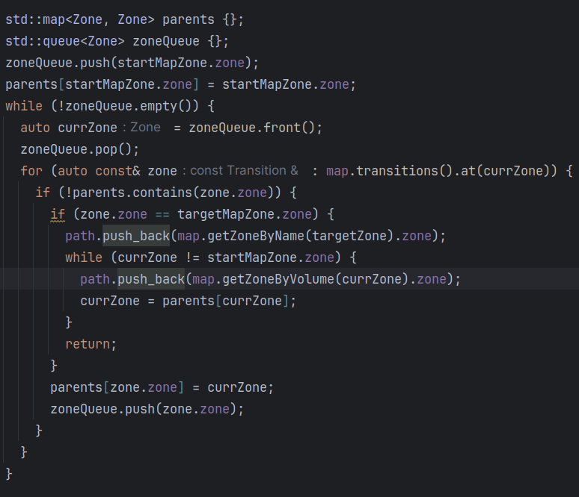**image 3.4.3.2** a BFS traversal to determine the shortest path to the target

* + - LocationChoosingTree: this tree is the most complex one; in order to find a way to traverse the environment, the granularity given by the Zones is way too large; mapping of smaller regions, however, would be a profoundly cumbersome task. Therefore an automatic mechanism is needed: the Subzone class presented earlier. Every Zone can be automatically divided into 10x10 smaller regions that allow running an in-zone algorithm to traverse the current zone towards the destination. Moreover, based on this division, the bot can also detect inaccessible zones as those subdivisions that intersect an obstacle. The algorithm is based on an A-Star navigation of the environment, with really high values associated with the obstacles such that the bot shall never choose a path going through an obstacle. The LocationChoosingTree also analyzes the game state to determine whether the bot shall target a camping spot or not (see section 3.4.2). In the end the *nextPosition* member in GameState is updated to propagate the information.
* AimingTree: this tree analyzes whether an enemy has recently been detected by looking both at the GameState to check for a new detection and at an internal state to determine the time of the last detection. If an enemy has been recently spotted, moving the aim would not be advised as the enemy may still be alive and therefore moving the aim may remove the enemy from the field of view, which would not be advised. This tree is also adaptable based on the current state: as can be seen in the diagram, each child is available based on a probability in the normal evaluation process. However, after planting the bomb the MovementOriented and BackCheckingOriented children would only confuse the bot; therefore, planting the bomb disables the two children (image 3.4.3.3)

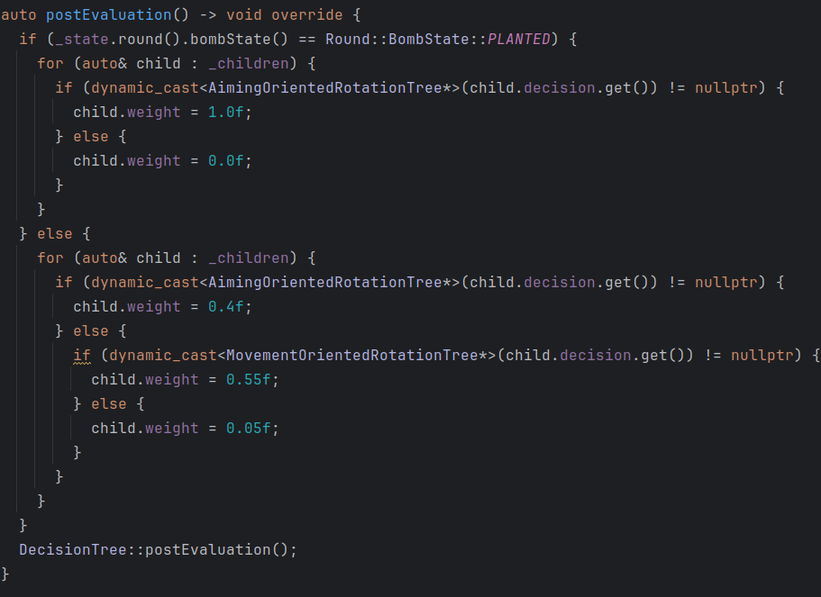**image 3.4.3.3** the AimingTree adapting to the current GameState

* + The children of the AimingTree all serve a simmilar purpose: to orient the bot towards a certain goal. This is done using basic 2-dimensional geometry: based on the current position and the target position associated with the goal, it computes the required angle; afterwards, the current orientation of the bot is obtained from the GameState and the needed rotation angle is computed.
  + MovementOrientedTree: the goal (as described above) simply uses the *nextPosition* member as the goal position.
  + BackCheckingOrientedTree: the rotation angle is directly computed to be 180 degrees (executing a complete turn) in order to check for the possibility of being flanked16 by an enemy.
  + AimingOrientedTree: this tree analyzes the current position and, using the Map, selects one of the possible watchpoints and sets it as the goal of the rotation.
* MovementTree: the tree uses the *nextPosition,* the current position and orientation to compute a movement vector that is than used as a customisation parameter for a MovementEvent/JumpEvent; the distinction between the two events is made by checking whether the current position corresponds to a transition zone registered in the map; based on the movement required to execute the transition, the produced event is customised.
* WeaponChoosingTree: the tree analyzes the inventory to determine the proper weapon that is to be used; depending on whether the active weapon and the target weapon match, the tree may produce an EmptyEvent as the weapon is already equiped; another aspect of concern to this tree is related to enemy detection; movement with the knife is faster, but it leaves the bot vulnerable if an enemy is present. Therefore, not detecting an enemy allows the WeaponChoosingTree to choose the knife as weapon.

As stated, two more trees are present in the hierarchy: the BuyingTree and the BombPlantingTree. They are special because they are SituationalTrees, meaning that only under certain circumstances is their evaluation required. The BuyingTree is only evaluated in the beginning of the round and if it hasn’t already been evaluated in the current round. The BombPlantingTree is only evaluated if the bomb is present in the player inventory, the current zone is A_SITE. Given that these trees are not always evaluated, they represent a special class of decision trees.

This concludes the analysis of the DecisionTree class hierarchy and allows us to examine the final component in the implementation, the main connector between the components, the Engine.

3.4.4 The Engine

The entire Engine class is an illustration of the Mediator pattern. The Engine is responsible for creating the threads of the three components previously mentioned (WindowController, PositionReader and GameStateIntegration communicator) and assuring their graceful exit upon termination. The Engine also creates the initial GameState that is passed to the DecisionTrees; for this reason it also builds the entire tree hierarchy so that the same GameState is passed to all the trees.

The most important feature of the Engine, however, is the passing of events: as mentioned, the WindowController exposes a queue for other classes to use in order to post events. However, only one class is responsible with posting events: the Engine. The reason behind this is that the usage of the queue for communication represents an example of the Producer-Consumer pattern. Although the design is multithread, if only one thread enqueues and only one thread dequeues there is no need for a synchronization mechanism when enqueueing or dequeueing. Although there exists a mechanism of synchronization between the Engine and the WindowController, it only exists to ensure that all the events passed so far have been treated, and not to prevent a data-race.

The sequence in which trees are passed is also dictated in the Engine (image 3.4.4.1).

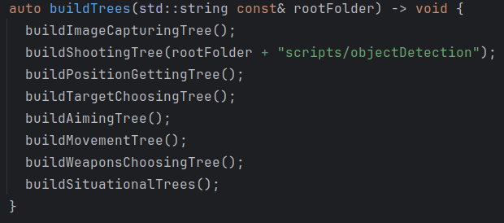**image 3.4.4.1** the order in which the trees are created gives the order in which they are evaluated

Having examined the Engine class as well, this concludes the implementation details of the application.

4. Tests and usage

Testing of the application implied two parts: first of all, the static elements, meaning classes not related to window interaction, could be tested with a standard framework; and second of all, the dynamic elements, meaning the DecisionTree hierarchy, the Event hierarchy and the multithreaded aspects were tested by running the application under certain parameters and examining the behaviour.

The static aspects were tested using UnitTest, with Google Test as the preffered framework. Of main interest in this part of testing was the LinearArray class. Considering the clearly defined mathematical results expected from such a class, testing required manual computation of the results before writing the actual tests (images 4.1a and 4.1b).

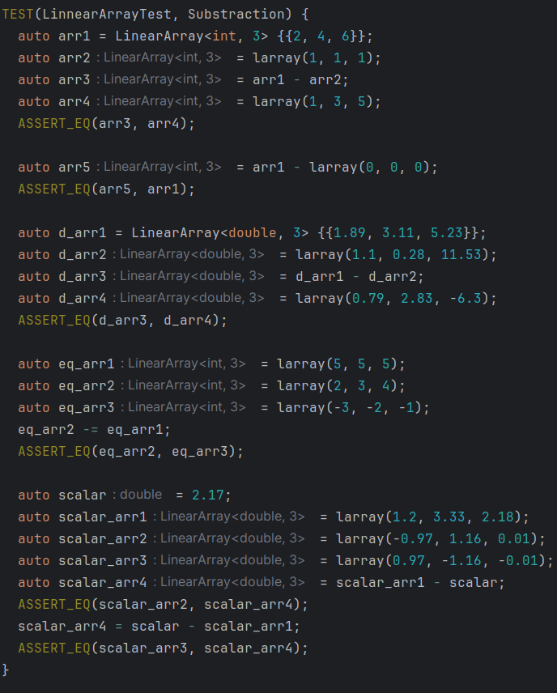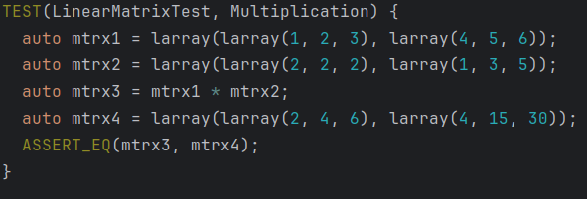

**images 4.1a** and **4.1b** unit tests of LinearArray using GTtest

In addition to testing using GoogleTest, I also used the coverage flags of the C++ compiler (-fcoverage-mapping, -fprofile-instr-generate for Clang) to ensure 100% coverage of the LinearArray class, which was obtained.

Other classes tested using UnitTests were the neural network related classes: Layer, ConvolutionalLayer, NeuralNetwork. In order to ensure that the networks implemented using the library were functional, I used two datasets, one for a normal neural network and one for a convolutional neural network, to see if models trained this way could obtain an expected accuracy.

For the standard neural network test, I used a dataset of 210 examples, with 7 attributes and 3 labels. The dataset was obtained from the Artificial Intelligence course in the 2023-2024 year, first semester. By defining a neural network with two hidden layers, the first of size 5 and using the sigmoid as activation function and the second of size 3 also using the sigmoid, and a final layer with the softmax acitvation function and the mean squared error cost function I managed to obtain an accuracy of over 90% after 250 epochs across multipled runs. The dataset was divided as 2/3 for training, and 1/3 for validation.

For the convolutional neural network, I used the well known MNIST dataset. The network can be seen in image 4.2. With only 10 epochs and a 0.005 training rate I manage to also obtain an accuracy of over 90%; although the expected accuracy for a CNN on MNIST is about 99%, the lower accuracy in my case is motivated by two aspects: firstly, the low number of epochs, and secondly, the lack of any kind of enhancer for the network.

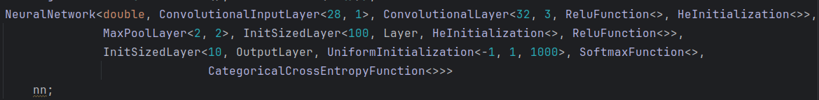**image 4.2** the CNN used for the MNIST dataset

The dynamic aspects were tougher to test, as the behaviour was highly non-deterministic. Debugging issues was also hard, as losing focus on the target window meant that events would no longer get processed. To ease the debugging process, I created a log method, used to display the status of operations (image 4.3). As it can be seen, the log method only has an effect in debug mode; in release mode, the function simply gets ignored.

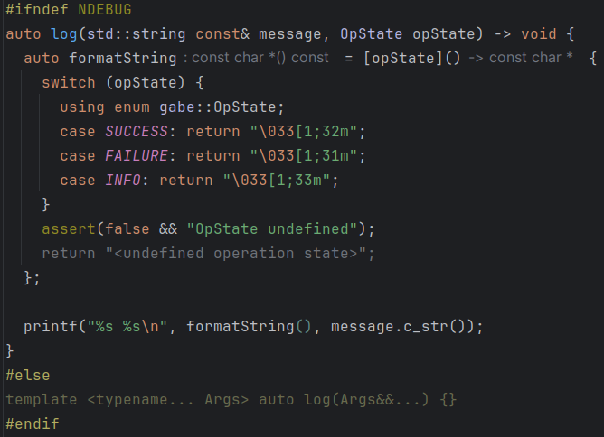**image 4.3** the log method used for debugging

Helpful for debugging was the developer console and the multitude of available commands. By using commands for bot freezing, lengthening rounds or invincibility I managed to test the bot without the need to go through multiple rounds at a single time, which would have introduced a considerable delay.

To ensure tracking of my progress with the application, I also created a specialiazed Steam account (image 4.4). Counter-Strike is free-to-play without Account Verification, meaning that the game does not protect matchmaking against cheaters as strongly. However, as I was only playing with bots in a private server, this aspect had no influence on the testing process. As can be seen in image 4.4, a little more than 40 hours have been invested in testing the application and gathering the necessary data for examining and mapping the environment.

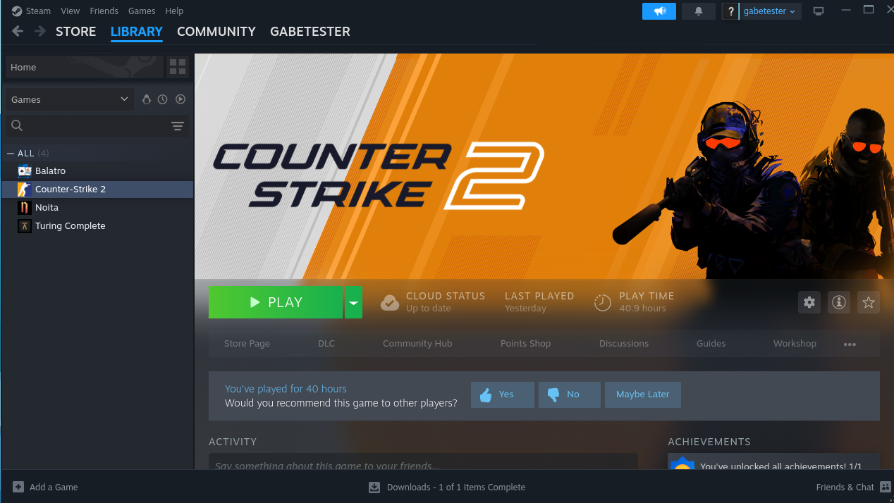**image 4.4** the specialized steam account used for testing

Application usage is quite straightforward: the main target for Cmake is the *main.cpp* file (image 4.5). As mentioned, it is required to pass the absolute path to the root folder where Counter-Strike is installed, as can be seen in the image. Having compiled the application, it can be directly run. If Counter-Strike is not opened and the window is not detected (it does not appear in the X11 hierarchy), the application will halt until the window is detected. Afterwards, it will start evaluating the decision trees and send events to the application as previously described.

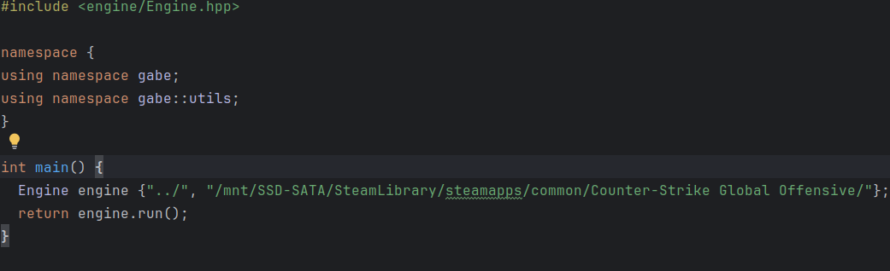

**image 4.5** the main file of the application

5. Conclusions

This project has been a really interesting endevaour for me, as it required knowledge in many subjects, such as Machine Learning, Operating Systems, Multithread application development, Software Engineering, Game design and Object Oriented programming. Developing this bot also taught me an important lesson regarding human behaviour: the project initially started with tremendous expectations of having not only a bot with perfect aim, but also with use of considerable mechanics. However, during development, the attempt to formalize what I consider human behaviour proved very difficult task. The way a player takes decision in Counter-Strike is a very complicated process, that also sometimes relies on one’s hunch. It would be impossible for a bot to synthesize and, moreover, exhibit such a behaviour.

The application also has a few shortcomings that could be worked upon and, naturally, features that could be added.

First of all, let us have a look at the defects:

* the Machine Learning library is functional, however due to a need for fast results in object detection it suffered from several bad decisions during development: currently, extension of the behaviour of the nets is difficult; the bright side is that I am fully aware of the modifications required to address the design issues and allow for the library to be further developed
* the object detection model failed; this is perhaps the greatest disappointment of the project. The main problem with this issue is that further knowledge of Machine Learning and neural networks is needed to address this issue. Also, the currently hard to extend design is also a setback, as adding additional features is not currently recommended.
* the application suffers from a deadlock that I have not managed to solve yet. The problem appears when the thread that issues a KeyPressEvent that in turn generates the *getpos* command and prompts the engine to log the current position in the file halts right before asking for a synchronization. The second thread manages to parse the file, and as no synchronization is currently needed, nothing is done. However, as the first thread resumes, it asks for a synchronization that will now never arrive, as the last *getpos* that it issued has already been treated.
* error handling is not well done throughout the application and this may lead to unexpected problems.
* movement of the bot does not take advantage of acceleration; given that the bot must, in quick succcession, both detect enemies, choose a weapon, a destination and move, the movement process cannot exceed a certain duration in time, therefore the bot stops periodically, even if it the pause is in the order of milliseconds. Due to this, the bot builds no velocity from continuous movement, and progresses slower than a normal player through the map.

There are also other issues, but of lesser importance, all of them fully documented in the github repository associated with this project at the issues section (https://github.com/StefanPaulet/GABE/issues).

Now, let us analyze the possible enhancements:

* the behaviour of the bot is currently quite rudimentary. As this project wished to be a proof-of-concept, there has been no considerable effort towards providing special behaviour to the bot. As can be noticed from the DecisionTree flowchart (image 3.4.3.1), there are not so many alternatives to its possible behaviour. The positive aspect is that behaviour augmentation is facile, as it is only required to specialize a certain tree and add it to the hierarchy. For example, prompting the bot to follow the path that provides the most cover can be easily done by adding a MovementTree that has a Policy that encourages a path alongside a wall (this can be easily achieved by customizing the heuristic used in the Astar algorithm).
* the bot adaptibility is very limited. As seen in section 3.4, only the AimingTree adapts to the current situation and alters the weights of its children. Although it is easy to create an adaptive tree, as it only implies modifying child weights, doing so directly is not the optimal way. A special mechanism would have to be designed in order to allow a more uniform update of the children weights.
* the actions of the bot currently receive no feedback; this enhancement is closely related to the previous one, as providing feedback to the actions is crucial for a good adaptive model. Currently, there is no base for such a feedback providing mechanism; however, it would increase the quality of the bot’s performance considerably.

In the end, I would like to thank my good friend Vlad Loghin for all the support provided during the development of this application, especially in the clean and efficient C++ code development section, but also in helping me bounce ideas off him, offering his own input, evaluating the quality of my code and of course developing the CDS library that provided me with the JSON parsing library.

6. References

[1] Chenyang Dai - Counter-Strike Self-play AI Agent with Object Detection and Imitation Training

[2] Joseph Redmon, Santosh Divvala, Ross Girshick, Ali Farhadi – You Only Look Once: Unified, Real-Time Object Detection

[3] https://developer.valvesoftware.com/wiki/Counter-Strike:_Global_Offensive_Game_State_Integration - The official Counter-Strike Game State Integration Wiki

[4] https://www.reddit.com/r/GlobalOffensive/comments/cjhcpy/game_state_integration_a_very_large_and_indepth/ - An in-depth analysis of Game State Integration

[5] https://developer.valvesoftware.com/wiki/Console_Command_List – The list of developer console commands

[6] https://counterstrike.fandom.com/wiki/Counter-Strike_Wiki – The offficial Counter-Strike Wiki

[7] Erich Gamma, Richard Helm, Ralph Johnson, John M. Vlissides - Design Patterns: Elements of Reusable Object-Oriented Software

[8] https://github.com/LoghinVladDev/CDS – Cpp library for JSON parsing

[9] https://eel.is/c++draft/ - the official C++ standard

[10] https://en.cppreference.com/w/ - C++ documentation

[11] https://deeplearning.cs.cmu.edu/F21/document/recitation/Recitation5/CNN_Backprop_Recitation_5_F21.pdf – backpropagation in convolutional neural networks

[12] https://stanford.edu/~shervine/teaching/cs-230/cheatsheet-convolutional-neural-networks – convolutional neural networks

[13] https://universe.roboflow.com/hieu-minh-yx9ep/csgo-2-hfa81 – Counter-Strike 2 YOLO dataset

[14] https://developer.valvesoftware.com/wiki/Command_line_options – Counter-Strike 2 launch options

7. Glossary

1. crosshair = the indicative icon highlighting the position that the bullets shot from the gun will hit

2. aiming = the process of moving your crosshair to another spot

3. recoil = the rearward thrust generated when a gun is being discharged; this is represented in the game through the weapon being fired becoming inaccurate; the crosshair reflects this as the shots tend to no longer follow the crosshair

4. spraying = continuous fire on a fully automatic weapon

5. spray-pattern = each weapon follows a predefined pattern of recoiling when continously fired

6. spray-control = the act of compensating for the spray-pattern during the act of spraying

7. tapping = executing single fire precise shots, with enough time between the shots to prevent the effects of recoil

8. headshot = a hit in the head, resulting in increased, most commonly fatal, damage

9. camp(ing) = staying in one position, usually behind cover, and waiting for the enemy to progress

10. wallhack = a cheat allowing the player to see enemies through the walls

11. aimhack = a cheat allowing a players aim to automatically move on a player’s head in inhumane speed

12. site = zone where the bomb can be planted by the Terrorists

13. spawn = zone where the teams start at the beginning of the round

14. ace = a single player eliminating the entire enemy team

15. clutch = winning the round while being the only player left alive of your team while the enemies have more members still alive

16. flanking = traversing the map in order to get behind the enemy and come from an unexpected position